**E-CAR**

**A PROJECT REPORT**

***Submitted by***

# ZAID Y MANSURI

**191260107041**

***In partial fulfillment for the award of the degree of***

# BACHELOR OF ENGINEERING

***in***

**Computer Engineering**

**Sal Engineering and Technical Institute, Ahmedabad**



# Gujarat Technology University, Ahmedabad

**May, 2023**

 

**Sal Engineering and Technical Institute**

**Opp. Science City,**

**Sola Bridge Road Ahmedabad, Gujarat-380060**

**CERTIFICATE**

This is to certify that the project report submitted along with the project entitled **E-Car** has been carried out by **Zaid Y Mansuri** under my guidance in partial fulfilment for the degree of Bachelor of Engineering in Computer Engineering, 8th Semester of Gujarat Technological University, Ahmedabad during the academic year 2022-23.

Prof. Jignyasa Gandhi Dr. Ajay Upadhyaya

Internal Guide Head of the Department

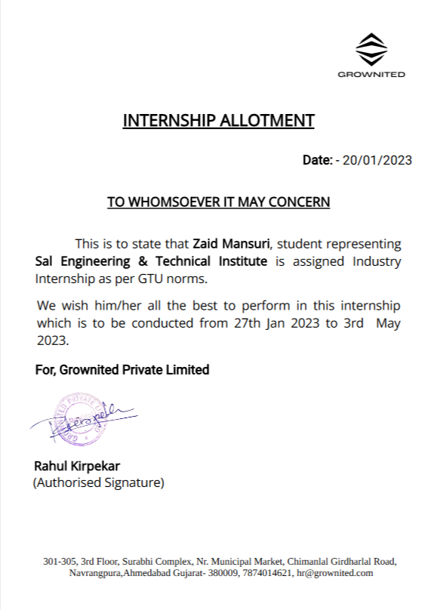

 

**Sal Engineering and Technical Institute**

**Opp. Science City,**

**Sola Bridge Road Ahmedabad, Gujarat-380060**

# DECLARATION

We hereby declare that the Internship report submitted along with the Internship entitled **E-Car** submitted in partial fulfilment for the degree of Bachelor of Engineering in Computer to Gujarat Technological University, Ahmedabad, is a Bonafide record of original project work carried out by me at Grownited under the supervision of Prof. Jignyasa Gandhi and that no part of this report has been directly copied from any students’ reports or taken from any other source, without providing due reference.

Name of the Student Sign of Student

_____________________ _______________

**Acknowledgment**

I am thankful to Sal Engineering and Technical Institute for giving me an opportunity to develop this project. Prof. Jignyasa Gandhi (Internal Guide) is the main force behind all these. The project became successful only because of their valuable suggestions, proper co-operation and complete guidance in developing this project. It was also the support from the staff members who spend their valuable time in providing us all the relevant and confidential college information which has helped us in preparing our project.

I am thankful to my guide who is the real source of inspiration and encouragement. His constant help, thoughtful suggestions and deep interest has enabled me to make this project successful. I also express my sincere thanks to our H.O.D, who allowed to use all the resources of the institute

I am thankful to all our staff members who helped continuously and inspired me in the project.

Yours sincerely,

ZAID MANSURI

(191260107041)

**ABSTRACT**

*E-Car system is a self-sustaining system which is the best opportunity for the people who cannot afford to buy the car in their family. Due to this system the people can borrow the car on rent for some time and do they compulsory work while paying the charges the rented car.*

*People need to peregrinate at different places due to their official work, family issues and other major things. If the travelling is of a more far distance then a person needs a car to because it is comfortable apart from the other public transport consequently people prefer car rather than public transport.*

*The public transport is not very flexible and halcyon like the trains, buses etc: ergo people call Self-car in lieu of other options. After the technology advancement, every family needs a personal conveyance for themselves because of the desideratum to peregrinate at different places which is far from their residence.*

*The proposed system provides an opportunity to the Middle Class people who cannot afford to buy a car even if they don't know how to drive the system provides driver option while charging a minimal amount for equipollent. The user can rent out a car according to his desideratum and his budget depending upon the number of people wants to peregrinate in a single car*

**List of Figures**

Figure 2.2.1 SDLC…………………………………………………………….10

Figure 3.7.1 Gantt Chart………………………………………………………23

Figure 4.5.1 Use Case System………………………………………………...26

Figure 4.5.2 Activity Diagram (Admin)………………………………………27

Figure 4.5.3 Activity Diagram (User)…………………………………………28

Figure 4.5.4 Sequence Diagram……………………………………………….29

Figure 4.5.5 E-R Diagram……………………………………………………..30

Figure 4.5.6 Class Diagram……………………………………………………31

Figure 5.3.2.1 Admin Flow Chart……………………………………………..45

Figure 5.3.2.2 User Flow Chart………………………………………………..46

Figure 5.3.3 State Chart Diagram……………………………………………...47

# Lists of Table

Table 5.2.1 Account Type……………………………………………………...36

Table 5.2.2 Category...…………….…………………………………………...37

Table 5.2.3 Expense……………….…………………………………………...37

Table 5.2.4 Income………………..……………………………………….…..38

Table 5.2.5 Status………………...…………………………………………….38

Table 5.2.6 Sub Category…...………………………………………………….38

Table 5.2.7 Users……………………………………………………………….39

Table 5.2.8 Vendor…………………...……………………………………...…39

# Abbreviations

**SDLC**

**Software Development Life Cycle**

Acknowledgement…………………………………………………………….... i

Abstract………………………………………………………………………… ii

List of Figures…………………………………………………………………. iii

List of Tables…………………………………………………………………... iv

List of Abbreviations…………………………………………………………... v

Table of Contents……………………………………………………………… vi

## Chapter 1 Overview of the Company…………………………………………1

1.1 About Company………………………………………………………1

1.2 Different product/scope of work……………………………………...1

1.3 Services……………………………………………………………….1

1.4 Capacity of Plant……………………………………………………...1

**Chapter 2 Overview of different plants/units/departments/shops of the organization and Layout of the production/process being carried**

## out in company……………………………………………………...2

2.1 List the technical specifications of major equipment used in each

department……………………………………………………………..2

2.2 Prepare a schematic layout which shows the sequence of operation for

manufacturing of end product…………………………………………3

2.3 Explain in details about each stage of production……………………..4

## Chapter 3 Introduction to Project ………………………………………...…..6

3.1 Project / Internship Summary………………………………………...6

3.2 Purpose……………………………………………………………….6

3.3 Objective……………………………………………………………...7

3.4 Scope………………………………………………………………....7

3.5 Technology and Literature Review……………,,……………………8

3.6 Project / Internship Planning………………………..………………10 3.6.1 Project / Internship Development Approach and

Justification………………………………………………..10

3.6.2 Project / Internship Effort and Time, Cost Estimation…….11

3.6.3 Roles and Responsibilities…………………………………14

3.7 Project / Internship Scheduling (Gantt Chart)………………………15

## Chapter 4 System Analysis……..…………………………………………….16

4.1 Study of Current System……………………………………………16

4.2 Problem and Weaknesses of Current System………………………16

4.3 Requirements of New System………………………………………16

4.4 System Feasibility…………………………………………………..16

4.4.1 Does the system contribute to the overall objectives of the

organization?........................................................................16

4.4.2 Can the system be implemented using the current technology

and within the given cost and schedule constraints……….17

4.5 Activity of New System…………………………………………….17

4.6 Features of New System…………………………………………….25

4.7 Modules and Their Description of System………………………….25

4.7.1 Signup / Login Module…………………………………….25

4.7.2 Customer Module.…………………………………………26

4.7.3 Service Provider Module…..………………………………27

4.7.4 Admin Module.……….……………………………………27

4.8 Selection of Hardware & Software Requirements………………….28

## Chapter 5 System Design……….…………………………………………….29

5.1 System Design………………………………………………………29

5.2 Database Design…………………………………………………….29

5.3 System Procedural Design………………………………………….39

5.3.1 Design Pseudo code or algorithm for method operation…..39

5.3.2 Flow Chart………………………………………………….41

5.3.3 State Chart Diagram………………………………………..44

### Chapter 6 Implementation…………………….……………………………..45

6.1 Implementation Platform / Environment……………………………45

6.2 Technology Specification…………………………………………...45 6.3 Results……………………………………………………………….46 6.2 Technology Specification…………………………………………...45 6.3 Results……………………………………………………………….46

**Chapter 7 Testing………….………………………………………………….54**

7.1 Testing Plan…………………………………………………………54

7.2 Test Result and Analysis……………………………………………55

7.2.1 Test Case…………………………………………………..55

## Chapter 8 Conclusion and Discussion………………………………………..56

8.1 Overall Analysis of Internship / Project Viabilities………………...56

8.2 Dates of surprise visit by institute mentor…………………………..56

8.3 Dates of Continuous Evaluation (CE-I and CE-II)………………….56

8.4 Problem Encountered and Possible Solutions……………………….56

8.5 Summary of Internship / Project work……………………………....57

8.6 Conclusion…………………………………………………………..57

8.7 Limitation and Future Enhancement………………………………..57

**References……………………………………………………………………..58**

# OVERVIEW OF THE COMPANY

## ABOUT COMPANY

GROWNITED PVT.LTD is a Consummate Custom Software Development company delivering splendid business IT Solutions and related services to customers across the globe. Its development services are led by our dedicated and passionate team to provide best industry practices combined with technology expertise and business domain knowledge to drive digital transformation. Its proficiency in understanding business challenges and professional competence allows us to create a better experience for our customers.

## DIFFERENT PRODUCT/ SCOPE OF WORK

It provides the work in many fields like Smart City, Organ Transplant Care, Learning Management System, School Management System, Online Learning For Schools, Forex Solution, Insurance Transportation And Language Services, Records Management System, Law Enforcement Application, ERP Solutions etc.

The famous work that company had done are Anglo-American, Macquarie University, FIJI Airways, Brightstar, SSE, mayflower, Xerox, PepsiCo, KFC etc

## Services

Grownited Pvt.ltd provides services in following field Web Development, Dedicated Development Team, Product Development, Ecommerce Development, Custom Software Development, Mobile Apps Development, Software Testing & QA, UI/UX Design.

**1.4 Capacity of Plant**

It has a capacity of approx. 1200 employee.

# Chapter 2

# OVERVIEW OF DEPARTMENT

**2.1 List the technical specifications of major equipment used in each department.**

## Backend

* Java
* Node js
* PHP
* ROR
* .Net

## Frontend

* Angular
* React
* Vue.js

## Database

* Microsoft SQL Server
* PostgreSQL
* Elastic Search
* MySQL
* Mongo DB
* Cassandra
* Oracle

## Clouds & DevOps

* AWS
* Google Cloud
* Docker
* Jenkins
* Kubernates
* Azure

## Mobile

* IOS
* Android
* React Native
* Flutter
* Xamarin

**2.2 Prepare schematic layout which shows the sequence of operation for manufacturing of end product.**

The production is carried out in following steps

1. Planning
2. Analysis
3. Design
4. Implementation
5. Testing and Integration
6. Maintenance

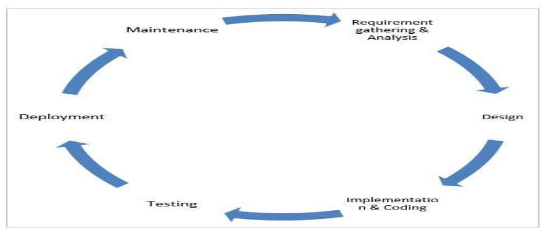

Figure 2.2.1 SDLC

**2.3 EXPLAIN IN DETAILS ABOUT EACH STAGE OF PRODUCTION.**

## 1) Requirement Gathering and Analysis

We have collected all the information regarding project. Oncerequirement gathering is done, an analysis is done to check the feasibility of the development of a product. Once the requirement is clearly understood, the SRS (Software Requirement Specification) document is created. This document should be thoroughly understood by the developers and also be reviewed by the customer.

## 2) Design

In this phase, the requirement gathered in the SRS document is used as an input and software architecture that is used for implementing system development is derived. We have design all the public pages like homepage, FAQ Page, contact us page, about us page, login page, signup page etc through HTML, CSS, JavaScript.

## 3) Implementing or Coding

Implementation/Coding started according to the requirement. The Software design is translated into source code. All the components of the software are implemented in this phase. Php, jQuery etc. is used for implementation. We used MVC Structure to for implementation.

## 4) Testing

Testing starts once the coding is complete and the modules are released for testing. In this phase, the developed software is tested thoroughly and any defects found are assigned back to get them fixed. Testers refer SRS document to make sure that the software is as per the customer’s standard.

## 5) Deployment

Once the product is tested, it is deployed in the production environment or first [UAT (User Acceptance testing)](https://www.softwaretestinghelp.com/what-is-user-acceptance-testing-uat/) is done depending on the customer expectation.

## 6) Maintenance

After the deployment of a product on the production environment, maintenance of the product i.e., if any issue comes up and needs to be fixed or any enhancement is to be done is taken care by the developers.

# Introduction to Project

## 3.1 PROJECT SUMMARY

* E-Car management system is a self-sustaining system which is the best opportunity for the people who cannot afford to buy the car in their family. Due to this system the people can borrow the car on rent for some time and do they compulsory work while paying the charges Of the rented Car..
* People need to peregrinate at different places due to their official work, family issues and other major things. If the travelling is of a more preponderant distance then a person needs a car to peregrinate because it is comfortable apart from the other public conveys consequently people prefer car rather than public convey.
* The public convey is not very flexible and halcyon like the trains, buses etc: ergo people cull self-car in lieu of other options. After the technology advancement, every family needs a personal conveyance for themselves because of the desideratum to peregrinate at different places which is far from their residence.
* The proposed system provides an opportunity to the middle class people who cannot afford to buy a car even if they don't know how to drive the system provides driver option while charging a minimal amount for equipollent. The user can rent out a car according to his desideratum and his budget depending upon the number of people wants to peregrinate in a single car.

* **Customers:**

Customer can signup and then login on the website and can book a car by entering the required details. Moreover, customer can book a car according to their choice which and budget. All cars are having different accessories in it.

### • Administration users (Administrators)

Admin or Backoffice users would be helping customers or service providers through the admin interface. For example, if any customer is having trouble cancelling or rescheduling the car booking request then admin can help using the admin interface.

## 3.2 PURPOSE

A car rental is a vehicle that can be used temporarily for a fee during a specified period. Getting a rental car helps people get around despite the fact they do not have access to their own personal vehicle or don't own a vehicle at all. The individual who needs a car must contact a rental car company and contact out for a vehicle. This system increases customer retention and simplify vehicle and staff management.

## 3.3 OBJECTIVE

* To produce a web-based system that allow customer to register and reserve car online and for the company to effectively manage their car rental business.

* To ease customer's task whenever they need to rent a car.

* Dedicated customer service to our customers and are guided in all we do by their needs. The team is always happy to support you and offer all the information you need.

* Customers can search car according to their need and accessories they want in a car.

## 3.4 Scope

This project traverses a lot of areas ranging from business concept to computing field, and required to perform several researches to be able to achieve the project objectives. The area covers include:

Car rental industry: This includes study on how the car rental business is being done, process involved and opportunity that exist for improvement.

General customers as well as the company's staff will be able to use the system effectively.

Web-platform means that the system will be available for access 24/7 except when there is a temporary server issue which is expected to be minimal.

It features a familiar and well thought-out, an attractive user interface, combined with strong searching insertion.

➢ Some Features-:

* Login/Register System.
* Easy Booking Procedure
* Friendly Customer Service
* Create/Manage Brands.
* Post/Manage Vehicle.
* Manage Bookings, Testimonials, Contact Queries and FAQ’S Pages.

## 3.5 Technology and Literature Review

### Literature Review/Background Study

We don’t have such an existing system proper like this but there is a similar system is there in the market: -

* We study all the existing system and they also provided the features but some Customers are facing the problem and from that we got an idea to build the project.
* Also, many customers faced problems regarding the user-friendly system.
* However, we got idea to provide the service with extra features and more user- friendly way.

### Technology

The front end used in our project is jQuery, HTML, JavaScript, CSS, and the back end used is MySQL. We will follow the Iterative model for developing this Project and whole Project will be developed using the SDLC scenario.

### HTML

HTML an initialize of Hyper Text Markup Language for web pages. It provides a means to describe the structure of text-based information in document by denoting text as headings, paragraphs, lists and so on and to supplement that text with interactive forms, embedded images and other objects.

### JavaScript

JavaScript supports the development of both client and server components of webbased applications. On the client side, it can be used to write programs that are executed by a web browser within the context of the web page. On the server side, it can be used to write web server programs that can be process information submitted by a web browser and then update the web browser display accordingly.

### PHP

PHP is a server scripting language, and a powerful tool for making dynamic and interactive Web pages. PHP is a widely-used, free, and efficient alternative to competitors such as Microsoft's ASP. PHP is an acronym for "PHP: Hypertext Preprocessor".

PHP is a widely-used, open-source scripting language. PHP scripts are executed on the server.

Benefit of the PHP:

* PHP can generate dynamic page content.
* PHP can create, open, read, write, delete, and close files on the server.
* PHP can collect form data.
* PHP can send and receive cookies.
* PHP can add, delete, modify data in your database
* PHP can be used to control user-access
* PHP can encrypt data

### SQL

* SQL (Structured Query Language) is a special-purpose programming language designed for managing data held in a relational database management system (RDBMS).
* Originally based upon relational algebra and tuple relational calculus, SQL consists of a data definition language and a data manipulation language.
* The scope of SQL includes data insert, query, update and delete, schema creation and modification, and data access control. Although SQL is often described as, and to a great extent is, a declarative language (4GL), it also includes procedural elements.
* Data Definition: Defining tales and structure in the database.
* Data manipulation: Used to manipulate the data within those schema objects.

## 3.6 Project Planning

Project Planning is concerned with identifying and measuring the activities, milestones and deliverables produced by the project. Project planning is undertaken and completed sometimes even before any development activity starts. Project planning consists of following essential activities:

* Scheduling manpower and other resources needed to develop the system.
* Staff organization and staffing plans.
* Risk identification, analysis, and accurate planning.
* Estimating some of the basic attributes of the project like cost, duration and efforts.

The effectiveness of the subsequent planning activities is based on the accuracy of these estimations. Project management involves planning, monitoring and control of the people, process and the events that occurs as the software evolves from a preliminary concept to an operational implementation. Cost estimation is a relative activity that is concerned with the resources required to accomplish the project plan.

### 3.6.1 Project Development Approach and Justification

A Software process model is a simplified abstract representation of a software process, which is presented from a particular perspective. A process model for software engineering is chosen based on the nature of the project and application, 14 the methods and tools to be used, and the controls and deliverables that are required. All software development can be characterized as a problem-solving loop which in four distinct stages is encountered:

* Requirement analysis
* Design
* Coding
* Testing
* Deployment

### 3.6.2 Project Effort and Time, Cost Estimation

#### Effort Estimation

Each company determines the output it expects from its team members. Let us call the average output of a team member per man-hour as the unit output. Assume that one has to deliver an end-to-end login module's functionality for an application. The time spent on the login functionality should include the corresponding time required for gathering the requirements, doing a requirement analysis, architecture inputs, form design, object/class design, implementing the business rules, data validation and storage, framework (i.e., code for login module's constants, enumerations, utilities), testing, debugging, deployment up to user acceptance, etc. Now, the estimator has to figure out how many man-hours it would take to complete the login module, keeping all these factors in mind.

The sequence of work and dependencies should be considered as they do cause delays in completion. For example, form design should be done first (all the way up to acceptance by the customer), then object design (up to acceptance by the architect), followed by coding (for business rules, calculations, and data validations), internal testing, and user acceptance testing. A wise estimator would always take support from other people to understand the scope of work to do a given task.

Implementing the business rules, data validation and storage, framework (i.e., code for login module's constants, enumerations, utilities), testing, debugging, deployment up to user acceptance, etc. Now, the estimator has to figure out how many man-hours it would take to complete the login module, keeping all these factors in mind. The sequence of work and dependencies should be considered as they do cause delays in completion. For example, form design should be done first (all the way up to acceptance by the customer), then object design (up to acceptance by the architect), followed by coding (for business rules, calculations, and data validations), internal testing, and user acceptance testing. A wise estimator would always take support from other people to understand the scope of work to do a given task.

#### Cost Estimation

The COCOMO Model Like all estimation models for software, the COCOMO models require sizing information. Three different sizing options are available as part of the model hierarchy: object points, function points, and lines of source code. Like function points, the object point is indirect software that is computed using counts of the number of

1. Screens (at the user interface),
2. Reports,
3. Components likely to be required to build the application.

Once complexity is determined, the number of screens, reports, and components are weighted according to Table above. The object point count is then determined by multiplying the original number of object instances by the weighting factor in table above and summing to obtain a total object point count.

When component-based development or general software reuse is to be applied, the percent of reuse (%reuse) is estimated and the object point count is adjusted: NOP = (object points) X [(100 - %reuse) / 100]. Where NOP is defined as new object points. To derive an estimate of effort based on the computed NOP value, a “productivity rate” must be derived. PROD=NOP / person-month.

For different levels of developer experience and development environment maturity. Once the productivity rate has been determined, an estimate of project effort can be derived as

Estimated effort = NOP/PROD.

There are three types of software project: Organic project, Semi-detached project, Embedded project.

Cost required to develop project=effort*rs/month

Effort Estimation (E):

In Organic=2.4 (KLOC) 1.05 PM

In semidetached=3.0(KLOC) 1.12 PM In Embedded=3.6(KLOC) 1.20 PM

Duration Estimation (D):

In Organic=2.5(effort) 0.38 months

In semidetached=2.5(effort) 0.35 months In Embedded=2.5((effort) 0.32 months Person Estimation: P=E/D

**Advantages of COCOMO:**

* COCOMO is factual and easy to interpret.
* One can clearly understand how it works.
* Accounts for various factors that affect cost of the project.
* Works on historical data and hence is more predictable and accurate.

#### Disadvantages

* COCOMO model ignores requirements and all documentation.
* It ignores customer skills, cooperation, knowledge and other parameters.
* It oversimplifies the impact of safety/security aspects.
* It ignores hardware issues It ignores personnel turnover levels It is dependent on the amount of time spent in each phase.

### 3.6.3 Roles and Responsibilities

This project defines the role and responsibilities of each and every phase involved in developing the system. To develop this system there was only one One member working on the whole application. I was responsible for each and every part of developing the system. staff members has sufficient knowledge in several programming languages.

1. **Customers**: Customers can signup and registration and then they can use all the services available on car rental portal.

1. **Administration Users:** Admin or Backoffice users would be helping customers or service providers through the admin interface. For example, if any customer is having trouble cancelling or rescheduling the service request then admin can help using the admin interface. Admin should be able to see all the registered users and should be able to approve first time registered users.

## 3.7 Project Scheduling (Gantt Chart)

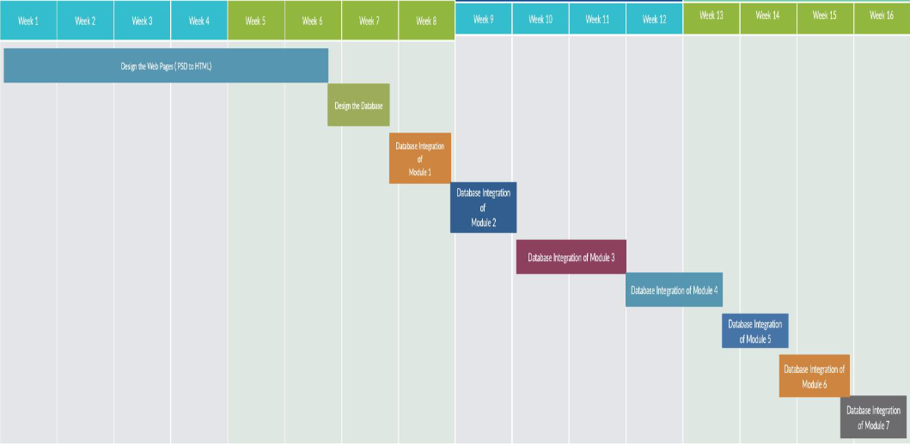

Fig 3.7.1 Gantt Chart

# System Analysis

## 4.1 Study of Current System

* Currently there is a system in the market named X-PRESS CAR which provides services for renting a car.
* It provides the services for cars with heavy charges.
* Its also provides driver if needed.
* It is unable to provide latest accessories.

## 4.2 Problem and Weakness of Current System

In this platform every time the new service providers provides the service So here; we can’t get another service with a chosen service provider. Here sometimes the service come from long distance so due to this they charge the heavy cost and its is a platform of all types of Cars like and not a specific car service.

## 4.3 Requirements of New System

In the new system, the users once get the service from providers and the users like’s it so another time they can directly book the service with a particular service provider.

It’s main purpose of this to provide Satisfaction service So the platform provides the service with multiple options. Here in this platform the nearby providers can provide the service to that area so due to that the costs of the service would be less compare to others in the market.

## 4.4 System Feasibility

**4.4.1 Does the system contribute to the overall objectives of the organization?**

Our project is capable to be implemented at an organization level. And, having objectives that outline an organization's focus can help employees stay focused and create cohesion in the workplace. These objectives should align with a company's vision and communicate its values. In this article, we discuss why the objectives of an organization are important, how to organize these objectives, the goals of organizational objectives and elements of good objectives. The objectives of an organization are important because they help every member of the organization, from stakeholders to entry-level employees, understand the company's mission.

**4.4.2 Can the system be implemented using the current technology and within the given cost and schedule constraints.**

We have implemented this project using the existing version of all the technologies used in it. We have not invested a single coin in this project. We have tried to cover all the user requirements to provide the maximum comfort to them, so we can achieve the long-term objectives with the maximum unique features of car. As requirements are gathered an overall version of system functions and features begins to materialize.

At project inception, software engineers ask a set of questions that establish:

* Basic understanding of problem.
* The people who want to use various services.

## 4.5 Activity of New System

**4.5.1 Use-Case:**

* In software and systems engineering, a use case is a list of steps, typically defining interactions between actor and a system, to achieve a goal.
* The actor can be a human, an external system, or time.
* In systems engineering, use cases are used at a higher level than within software engineering, often representing missions or stakeholder goals.
* The detailed requirements may then be captured in Systems Modeling Language or as contractual statements.
* As an important requirement technique, use cases have been widely used in modern software engineering over the last two decades.
* Use case driven development is a key characteristic of process models and frameworks.
* With its iterative and evolutionary nature, use case is also a good fit for agile development.

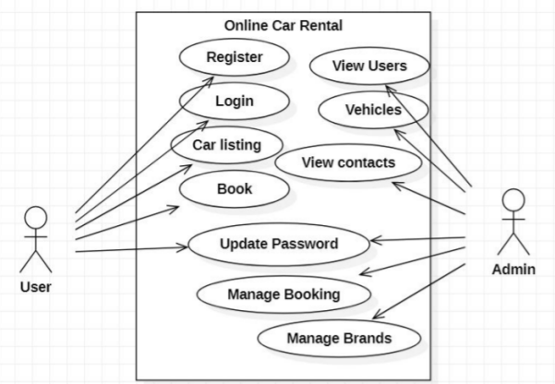

Figure 4.5.1 Use-Case System

**4.5.2 Activity Diagram**

### Admin

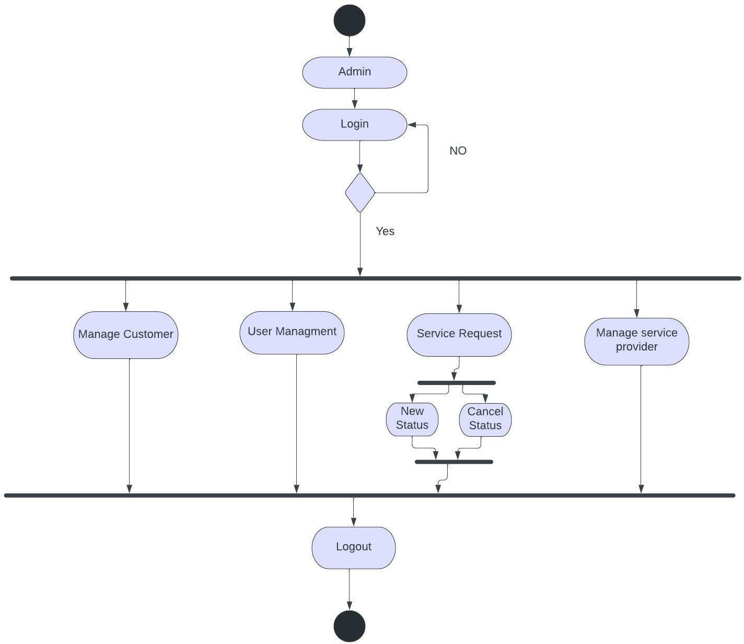

Figure 4.5.2 Activity Diagram (Admin)

**4.5.3 User Diagram**

### User

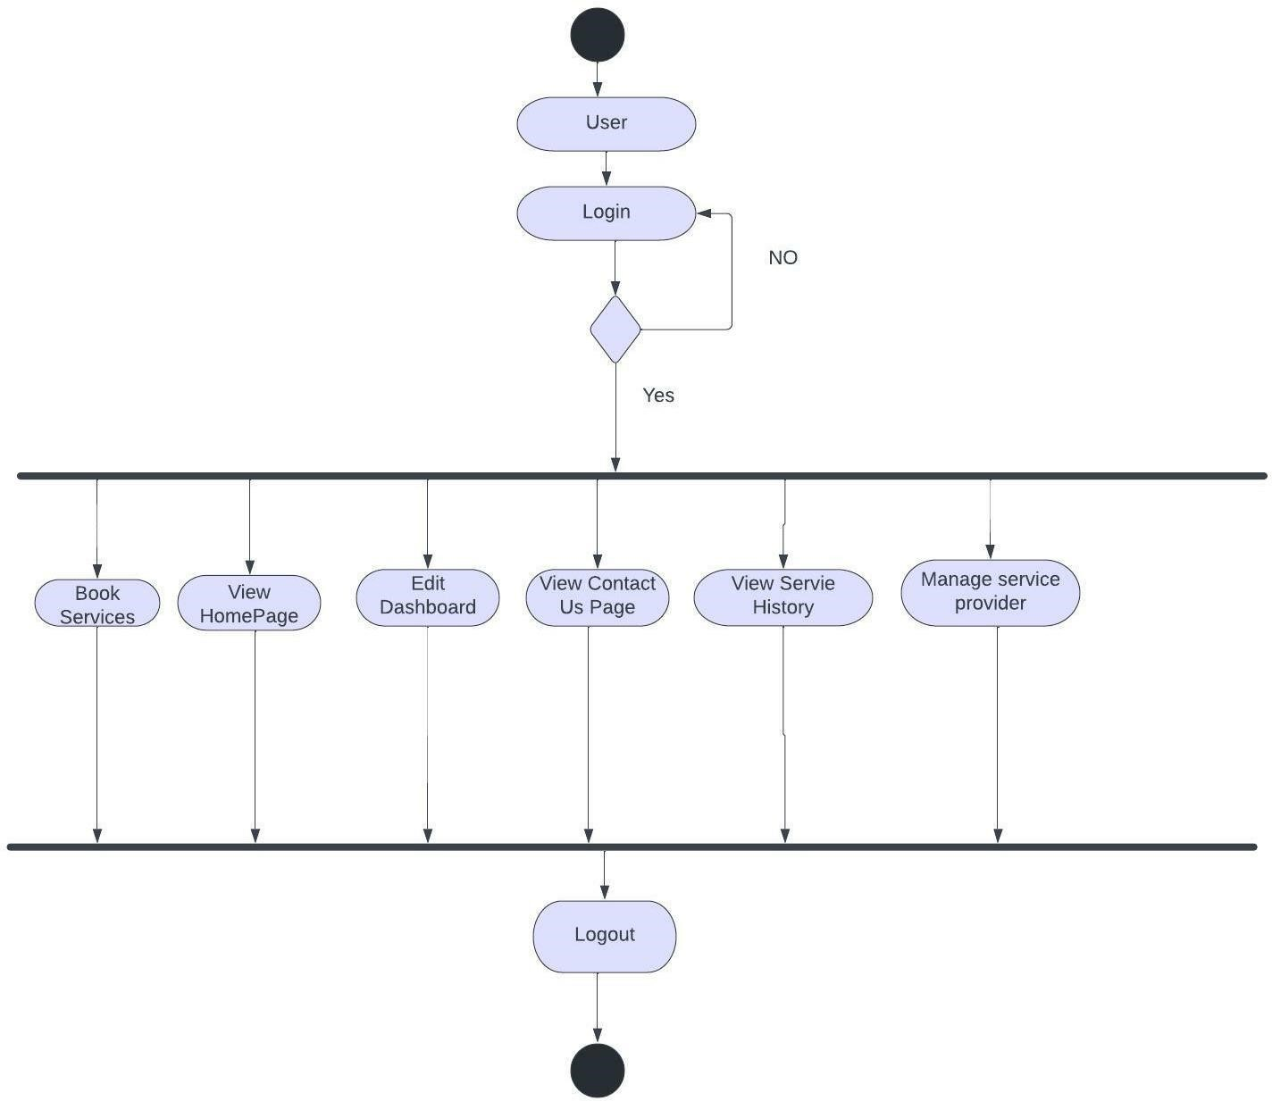

Figure 4.5.3 Activity Diagram (User)

### 4.5.4 Sequence Diagram

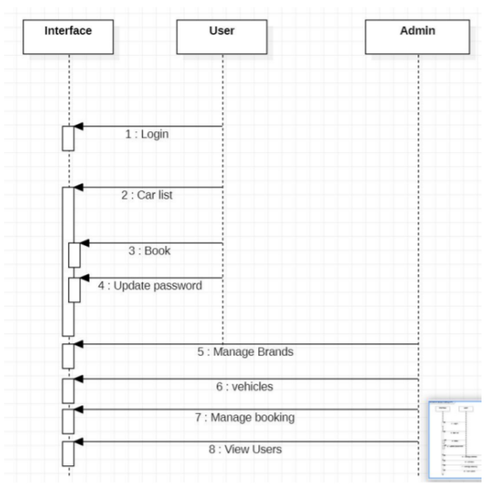

Figure 4.5.4 Sequence Diagram

### 

### 4.5.5 E-R Diagram

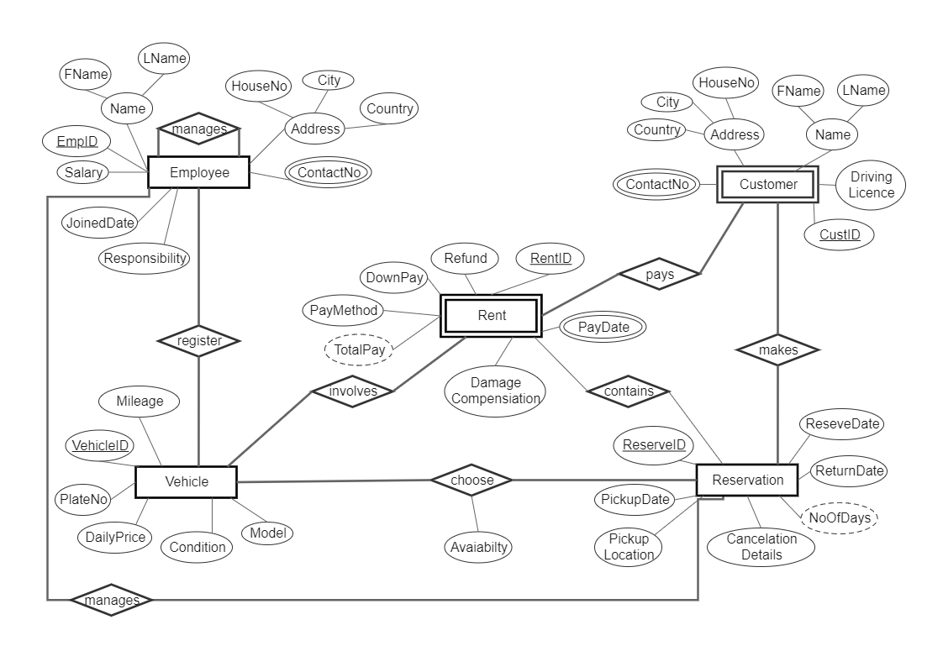

Figure 4.5.5 E-R Diagram

### 4.5.6 Class Diagram

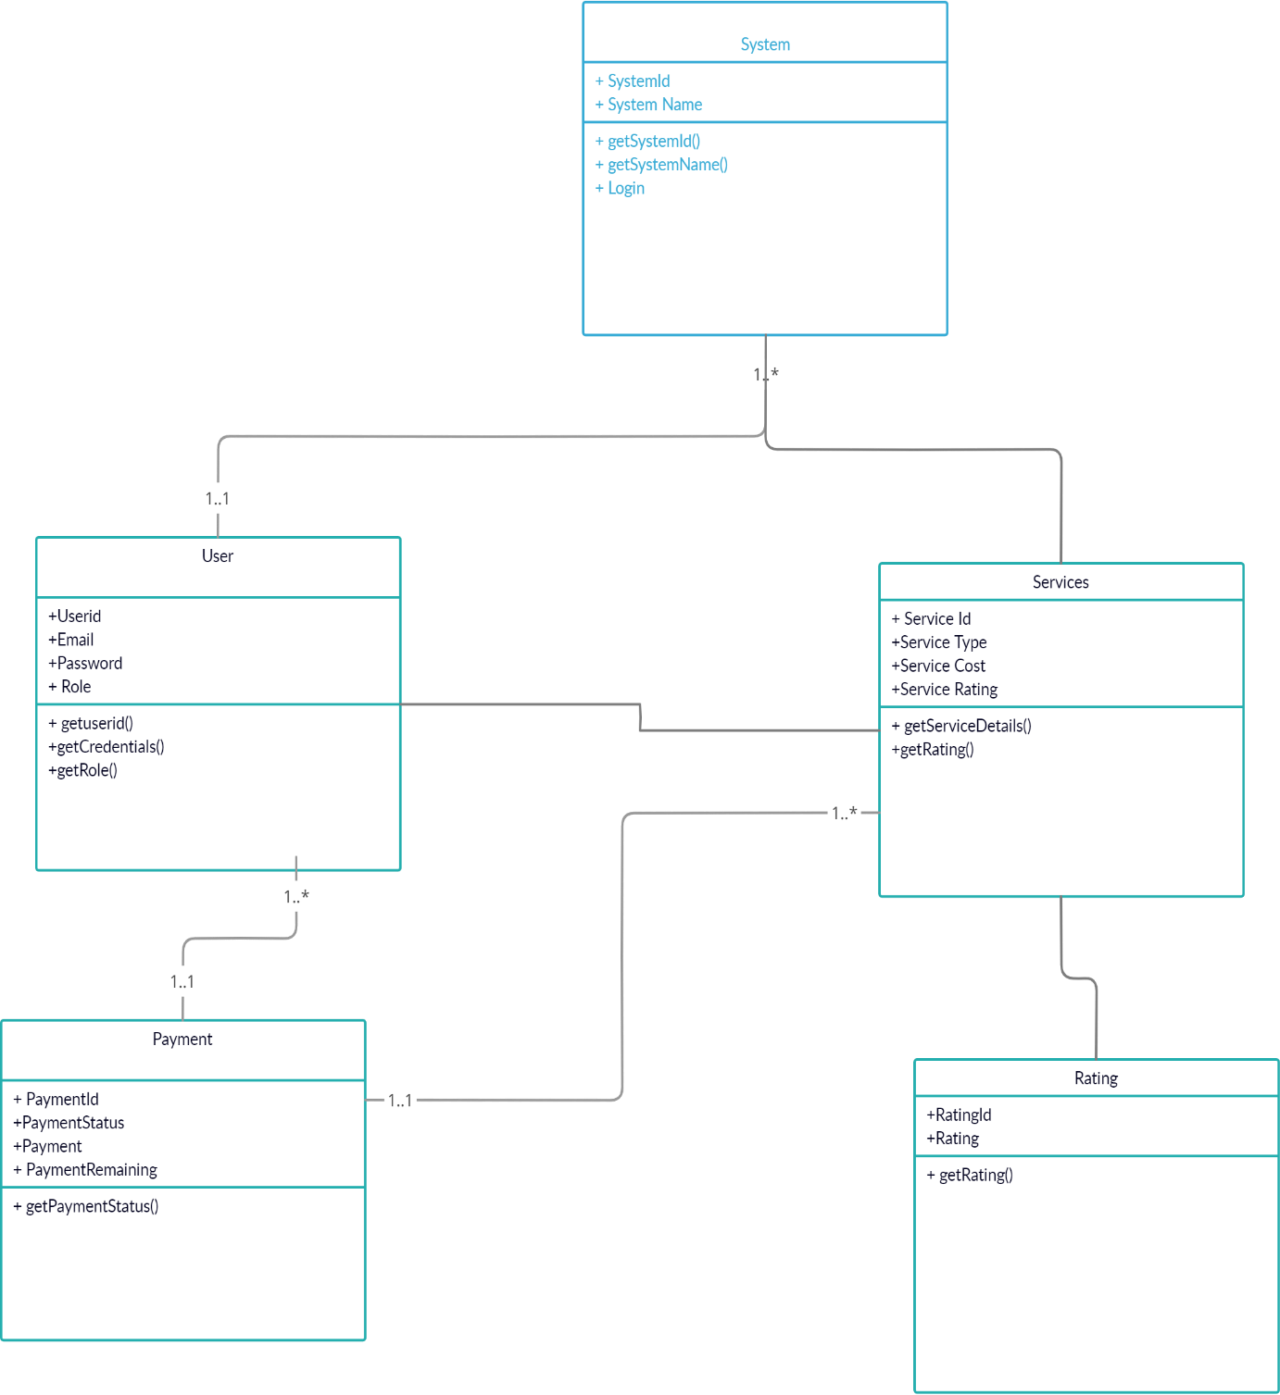

Figure 4.5.6 Class Diagram

## 4.6 Features of New System

### Friendly & Certified admin

We want you to be completely satisfied with our service and feel comfortable at home. In order to guarantee this, our helpers go through a test procedure. Only when the cleaners meet our high standards, they may call themselves Helper.

### Contact us

If the user finds any difficulty in using the web application he /she can easily contact us and the manager can easily resolve the queries via contact us form.

### Easy bookings

Booking is processed securely online. Customers use safely online and manage the booking.

## 4.7 Modules and Their Description of System

**4.7.1 Signup/ Login Module**

### Login

Clicking on Login link in header should open a popup and allow user to log in to the system. This Login screen would be central place to allow different types of users logging in to the system i.e., Customer, Service Provider and Admin users. This would redirect them to respective landing page.

### Signup

Customers should be able to register themselves using sign up screen. This should be a separately designed page where users would be redirected when they click on Create New Account link in Login Dialog. Customers should straightaway be able to login to the system once they create their account with Car rental.

**4.7.2 Customer ‘s Module**

### Dashboard

* Customers should be able to view their booked service requests on the dashboard. This screen should show only future service requests which are not completed or cancelled.
* The service request listing must show the fields as shown in the above image.
* If a service request has not been accepted by any of the service provider yet then it would show Service Provider field blank as shown in above screenshot.
* If a service request has been accepted by a service provider, then Service provider should show the avatar and the name of assigned service provider.

Also, it should show the average rating underneath name.

* Customer should be able to see service request details by clicking on a row.
* Reschedule and cancel buttons should be displayed on the popup Service Provider screens

### Setup Service

* First, they need to enter a postal code where they would like to get cleaning job done.
* Once customer enters postal code and presses button Check Availability, the system will check if service providers providing service around this postal code! If any provider found then user should be navigated to the next tab.
* In case if no service provider providing the service for a particular zip code then user should stay on the same screen and should show the following error below the zip code button

“We are not providing service in this area. We’ll notify you if any helper would start working near your area.”

* Required field validation and zip code custom validation is required on this screen.

**4.7.3 Service Provider Module**

### New Service Requests

* The screen should allow service provider accessing the service request booked by the customers but yet not accepted by any of the service provider.
* The first service provider who would accept, will get the service request assigned. Rest of the service providers who are providing the service in this area would get notified by email that this service request has already been accepted by someone and is no more available to them.
* The listing should show the customer address as shown in the image below.

### Upcoming Services

* This screen will show only upcoming service requests assigned to the loggedin service provider. Service provider should be able to cancel the service request.
* There should be an additional button “Complete” for the service requests showed only whose service end date time (Start time + number of service hours) is lesser than the current date and time. A service request should be marked as completed when the service provider mark it as complete using this button.

**4.7.4 Admin Module**

### Service Requests

• Admin should be able to see all the service requests on this screen. Filters mentioned in below screenshot should allow admin to filter out records. Admin should be able to reschedule or cancel the service request on behalf of the customer of service provider. This option should only be available for the service requests which are not completed.

### User Management

• Admin should also manage all the users. It can Active or Deactivate the Users.

So by deactivating the users the users would not login in the system.

## 4.8 Selection of Hardware and Software Characteristics

### Hardware Requirements

* Minimum 2.27Ghz processor
* RAM: 4GB minimum Software Requirements.
* PHP compatible system 18 Hardware requirement for PHP Portal Development.

### Software Requirements

* Visual Studio Code (For live preview)
* SQL Database
* XAMPP
* Apache

# System Design

## 5.1 System Design & Methodology

Systems design is the process of defining the architecture, components, modules, interfaces, and data for a system to satisfy specified requirements. The System Design Description report provides summary or detailed information about a system design represented by a model. Systems design is therefore the process of defining and developing systems to satisfy specified requirements of the user.

## 5.2 Database Design

Database design is the process of producing a detailed data model of a database. This logical data model contains all the needed logical and physical design choices and physical storage parameters needed to generate a design in a Data Definition Language, which can then be used to create a database. A fully attributed data model contains detailed attributes for each entity.

### E-CAR – DataDictionary

Table 5.2.1: City

|  |  |  |  |  |
| --- | --- | --- | --- | --- |
| **Table Name** | **City** |  |  | |
| **Field Name** | **Data**  **Type** | **Length** | **Nullable** | **Comments** |
| Id | Int | 10 | No | Its Primary Key. |
| CityName | Nvarchar | 50 | No |  |
| StateId | Int | 10 | No | Its Foreign key of State Table. |

Table 5.2.2: Contact US

|  |  |  |  |  |
| --- | --- | --- | --- | --- |
| **Table Name** | **ContactUs** |  |  |  |
| **Field Name** | **Data Type** | **Length** | **Nullable** | **Comments** |
| ContactUsId | Int |  | No | Its Primary Key. |
| Name | Nvarchar | 50 | No |  |
| Email | Nvarchar | 200 | No |  |
| SubjectType | Nvarchar | 100 | No |  |
| Subject | Nvarchar | 500 | Yes |  |
| PhoneNumber | Nvarchar | 20 | No |  |
| Message | Nvarchar | 0 | No |  |
| UploadFileName | Nvarchar | 100 | Yes |  |
| CreatedOn | Datetime |  | Yes |  |
| CreatedBy | Int |  | Yes |  |
| Status | Int |  | Yes |  |
| Priority | Int |  | Yes |  |
|  |  |  |  |  |
| AssignedToUser | Int |  | Yes |  |
| IsDeleted | Bit |  | No |  |

Table 5.2.3: ContactUsAttachment

|  |  |  |  |  |
| --- | --- | --- | --- | --- |
| **Table Name** | **ContactUsAttachment** | |  |  |
| **Field Name** | **Data Type** | **Length** | **Nullable** | **Comments** |
| ContactUsAttachmentId | Int | 10 | No | Its Primary Key. |
| Name | Nvarchar | 100 | No |  |
| FileName | Varbinary |  | No |  |

Table 5.2.4: FavoriteAndBlocked

|  |  |  |  |  |
| --- | --- | --- | --- | --- |
| **Table Name** | **FavoriteAndBlocked** | | |  |
| **Field Name** | **Data**  **Type** | **Length** | **Nullable** | **Comments** |
| Id | int |  | No | Its Primary Key. |
| UserId | int |  | No | Its Foreign key of User Table. |
| TargetUserId | int |  | No | Its Foreign key of User Table. |
| IsFavorite | bit |  | No |  |
| IsBlocked | bit |  | No |  |

Table 5.2.5: ServiceRequestExtra

|  |  |  |  |  |
| --- | --- | --- | --- | --- |
| **Table Name** | **ServiceRequestExtra** | | | |
| **Field Name** | **Data**  **Type** | **Length** | **Nullable** | **Comments** |
| ServiceRequestExtraId | Int |  | No | Its Primary Key. |
| ServiceRequestId | Int |  | No | Its Foreign key of ServiceRequest Table. |
| ServiceExtraId | Int |  | No |  |

Table 5.2.6: Rating

|  |  |  |  |  |
| --- | --- | --- | --- | --- |
| **Table Name** | **Rating** |  |  |  |
| **Field Name** | **Data**  **Type** | **Length** | **Nullable** | **Comments** |
| RatingId | int |  | No | Its Primary Key. |
| ServiceRequestId | int |  | No | Its Foreign key of  ServiceRequest Table. |
| RatingFrom | int |  | No | Its Foreign key of User Table. |
| RatingTo | int |  | No | Its Foreign key of User Table. |
| Ratings | decimal | 5 | No |  |
| Comments | nvarchar | 2000 | Yes |  |
| RatingDate | datetime |  | No |  |
| IsApproved | bit |  | Yes |  |
| VisibleOnHomeScreen | bit |  | No |  |
| OnTimeArrival | decimal | 5 | No |  |
| Friendly | decimal | 5 | No |  |
| QualityOfService | decimal | 5 | No |  |

Table 5.2.7: ServiceRequest

|  |  |  |  |  |
| --- | --- | --- | --- | --- |
| **Table Name** | **ServiceRequest** | | | |
| **Field Name** | **Data Type** | **Length** | **Nullable** | **Comments** |
| ServiceRequestId | Int |  | No | Its Primary Key. |
| UserId | Int |  | No | Its Foreign key of User Table. |
| ServiceId | Int |  | No |  |
| ServiceStartDate | Datetime |  | No |  |
| ZipCode | Nvarchar | 10 | No |  |
| ServiceFrequency | Tinyint |  | Yes |  |
| ServiceHourlyRate | Decimal | 5 | Yes |  |
| ServiceHours | Float |  | No |  |
| ExtraHours | Float |  | Yes |  |
| SubTotal | Decimal | 5 | No |  |
| Discount | Decimal | 5 | Yes |  |
| TotalCost | Decimal | 5 | No |  |
| Comments | Nvarchar | 500 | Yes |  |
| PaymentTransactionRefNo | Nvarchar | 50 | Yes |  |
| PaymentDue | Bit |  | No |  |
| JobStatus | Tinyint |  | Yes |  |
| ServiceProviderId | Int |  | Yes | Its Foreign key of User Table. |
| SPAcceptedDate | Datetime |  | Yes |  |
| HasPets | Bit |  | No |  |
| Status | Int |  | Yes |  |
| CreatedDate | Datetime |  | No |  |
| ModifiedDate | Datetime |  | No |  |
| ModifiedBy | Int |  | Yes |  |
| RefundedAmount | Decimal | 5 | Yes |  |
| Distance | decimal | 9 | No |  |
| HasIssue | bit |  | Yes |  |
| PaymentDone | bit |  | Yes |  |
| RecordVersion | uniqueidentifier |  | Yes |  |

Table5.2.8: ServiceRequestAddres

|  |  |  |  |  |
| --- | --- | --- | --- | --- |
| **Table Name** | **ServiceRequestAddress** | | | |
| **Field Name** | **Data**  **Type** | **Length** | **Nullable** | **Comments** |
| Id | int |  | No | Its Primary Key. |
| ServiceRequestId | int |  | Yes | Its Foreign key of  ServiceRequest Table. |
| AddressLine1 | nvarchar | 200 | Yes |  |
| AddressLine2 | nvarchar | 200 | Yes |  |
| City | nvarchar | 50 | Yes |  |
| State | nvarchar | 50 | Yes |  |
| PostalCode | nvarchar | 20 | Yes |  |
| Mobile | nvarchar | 20 | Yes |  |
| Email | nvarchar | 100 | Yes |  |
| Type | int |  | Yes |  |

Table 5.2.9: UserAddress

|  |  |  |  |  |
| --- | --- | --- | --- | --- |
| **Table Name** | **UserAddress** | | | |
| **Field Name** | **Data Type** | **Length** | **Nullable** | **Comments** |
| AddressId | Int |  | No | Its Primary Key. |
| UserId | Int |  | No | Its Foreign key of User Table. |
| AddressLine1 | Nvarchar | 200 | No |  |
| AddressLine2 | Nvarchar | 200 | Yes |  |
| City | Nvarchar | 50 | No |  |
| State | Nvarchar | 50 | Yes |  |
| PostalCode | Nvarchar | 20 | No |  |
| IsDefault | Bit |  | No |  |
| IsDeleted | Bit |  | No |  |
| Mobile | nvarchar | 20 | Yes |  |
| Email | nvarchar | 100 | Yes |  |
| Type | Int |  | Yes |  |

Table 5.2.10: User

|  |  |  |  |  |
| --- | --- | --- | --- | --- |
| **Table Name** | **User** | |  |  |
| **Field Name** | **Data Type** | **Length** | **Nullable** | **Comments** |
| UserId | Int |  | No | Its Primary Key. |
| FirstName | Nvarchar | 100 | No |  |
| LastName | Nvarchar | 100 | No |  |
| Email | Nvarchar | 100 | No |  |
| Password | Nvarchar | 100 | Yes |  |
| Mobile | Nvarchar | 20 | No |  |
| UserTypeId | Int |  | No |  |
| RoleId | Int |  | Yes |  |
| Gender | Int |  | Yes |  |
| DateOfBirth | Datetime |  | Yes |  |
| WebSite | Nvarchar | 1000 | Yes |  |
| UserProfilePicture | Nvarchar | 200 | Yes |  |
| IsRegisteredUser | Bit |  | No |  |
| PaymentGatewayUserRef | Nvarchar | 200 | Yes |  |
| ZipCode | Nvarchar | 20 | Yes |  |
| WorksWithPets | Bit |  | No |  |
| LanguageId | Int |  | Yes |  |
| NationalityId | Int |  | Yes |  |
| ResetKey | Nvarchar | 200 | Yes |  |
| CreatedDate | Datetime |  | No |  |
| ModifiedDate | Datetime |  | No |  |
| ModifiedBy | Int |  | No |  |
| IsApproved | Bit |  | No |  |
| IsActive | Bit |  | No |  |
| IsDeleted | Bit |  | No |  |
| Status | Int |  | Yes |  |
| IsOnline | Bit |  | No |  |
| BankTokenId | Nvarchar | 100 | Yes |  |
| TaxNo | Nvarchar | 50 | Yes |  |

### Screenshots

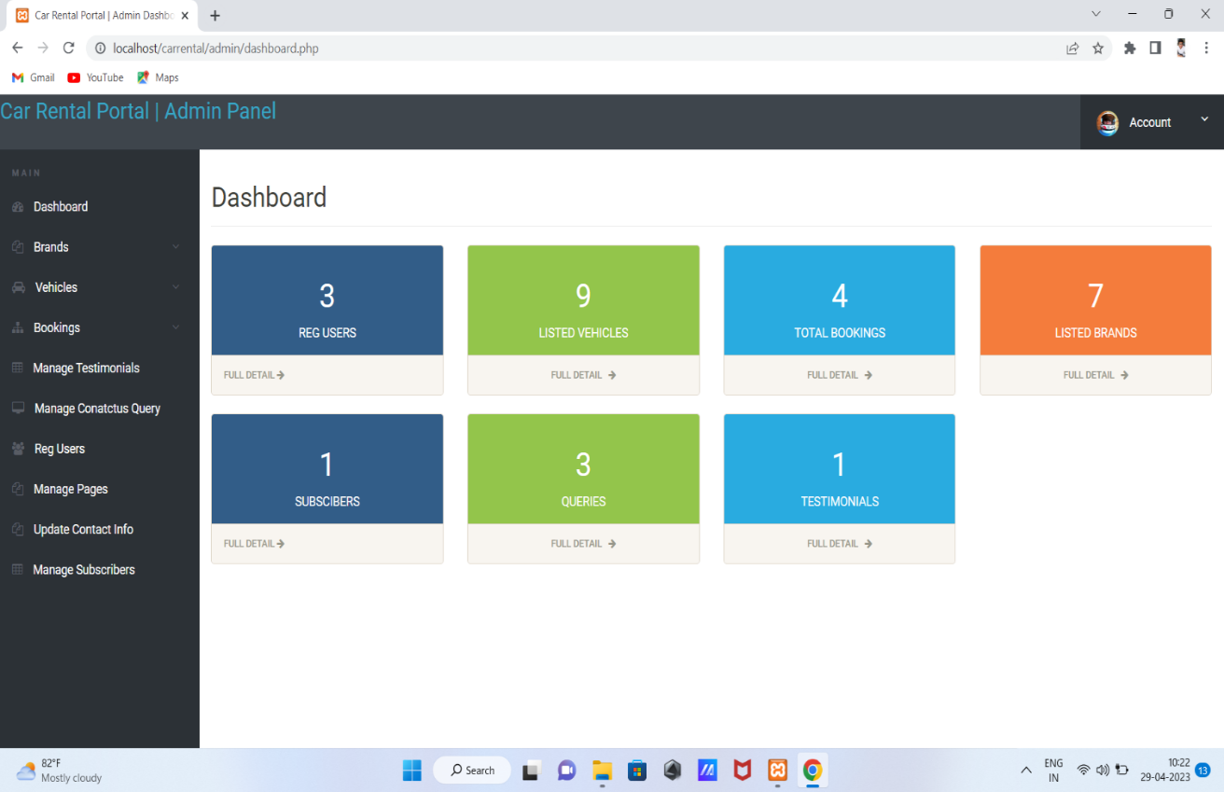

Figure 5.2.1 Admin Dashboard

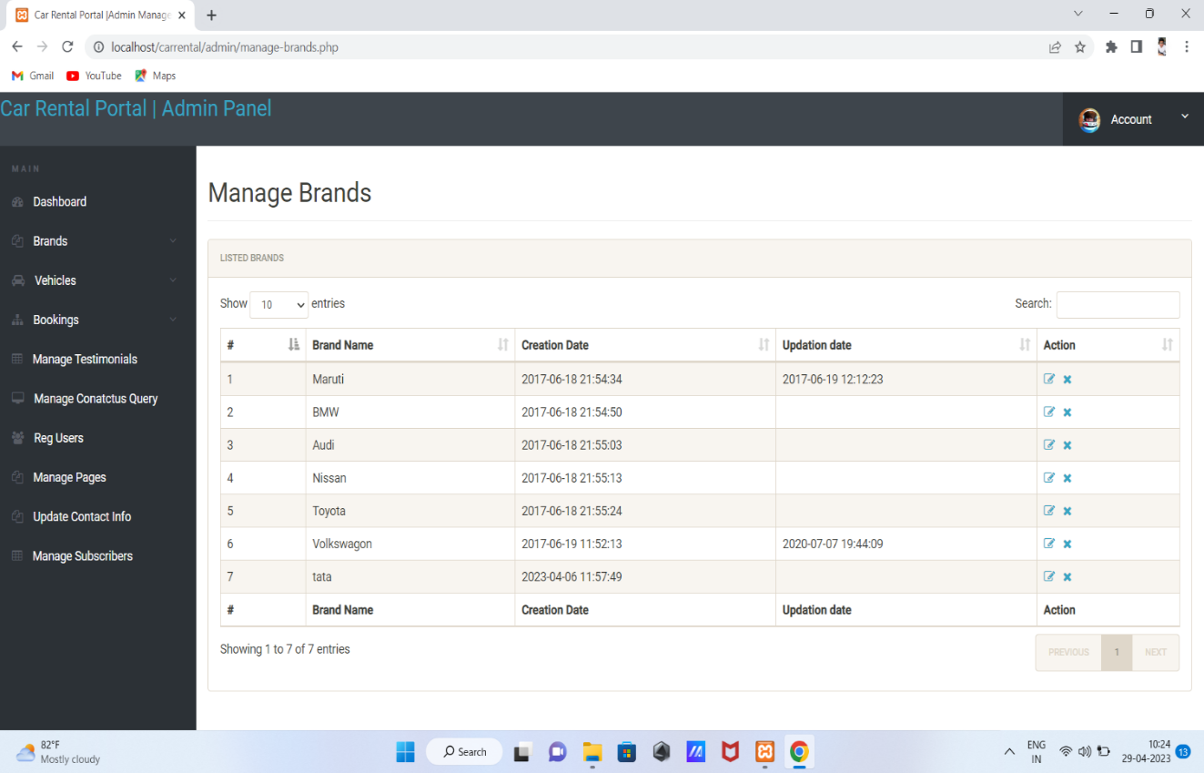

Figure 5.2.2 Manage Brands DB

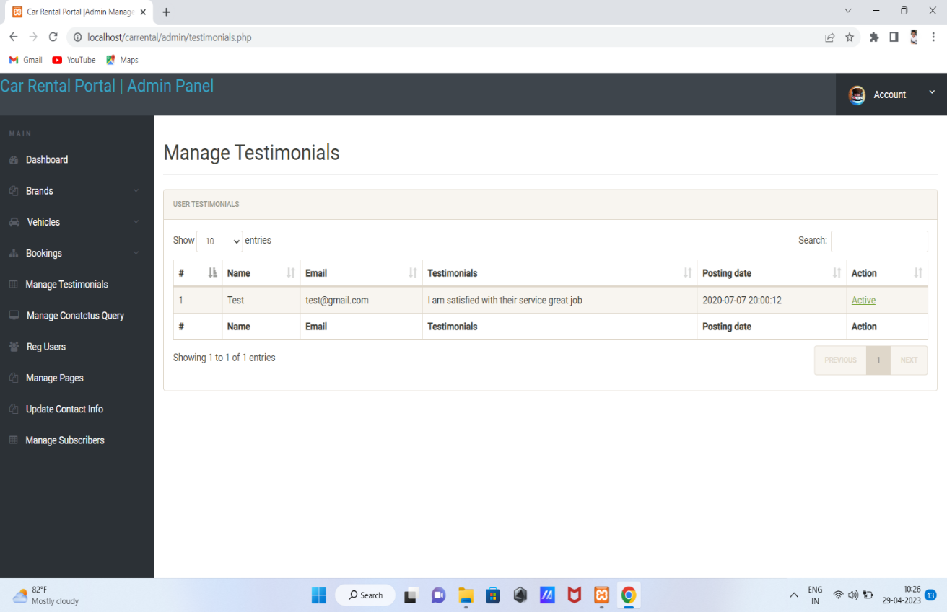

Figure 5.2.3 Rating DB

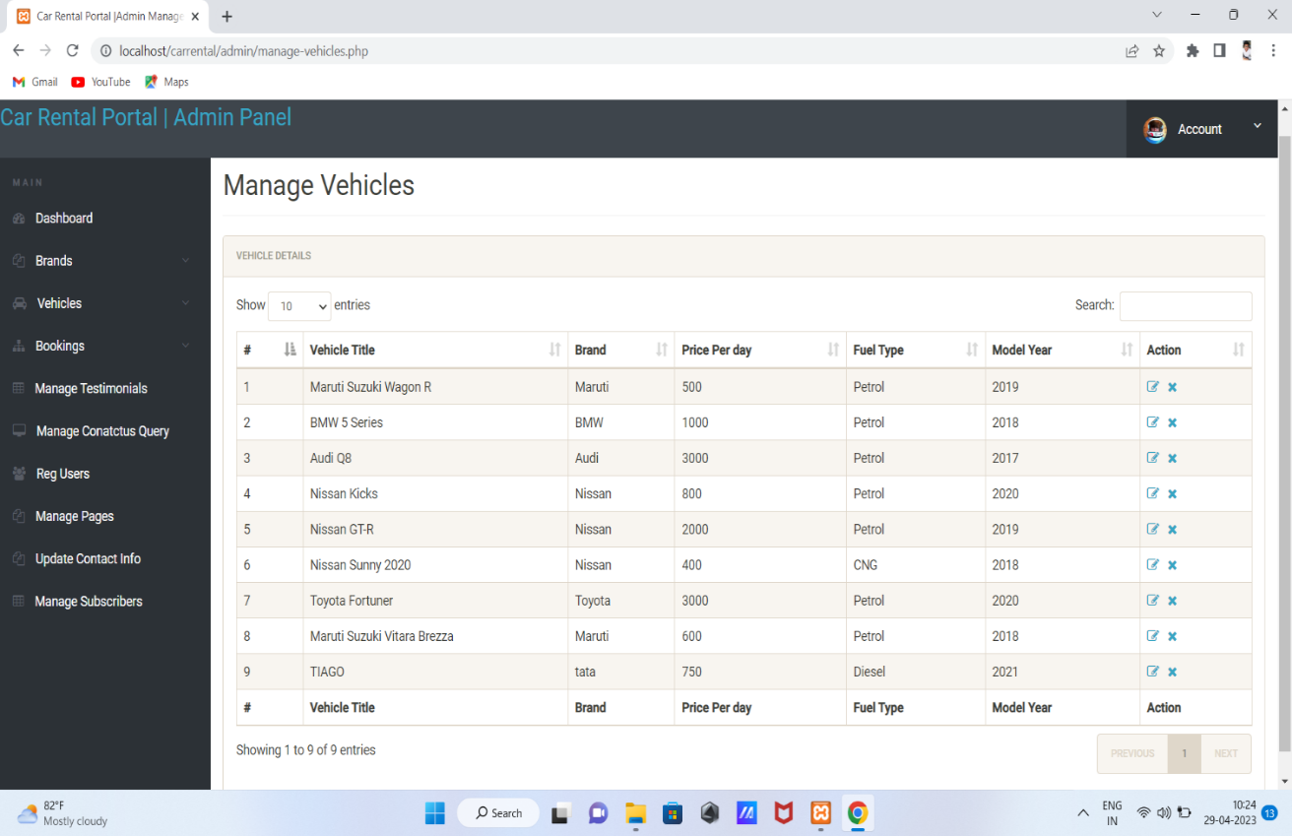

Figure 5.2.4 Manage Vehicles DB

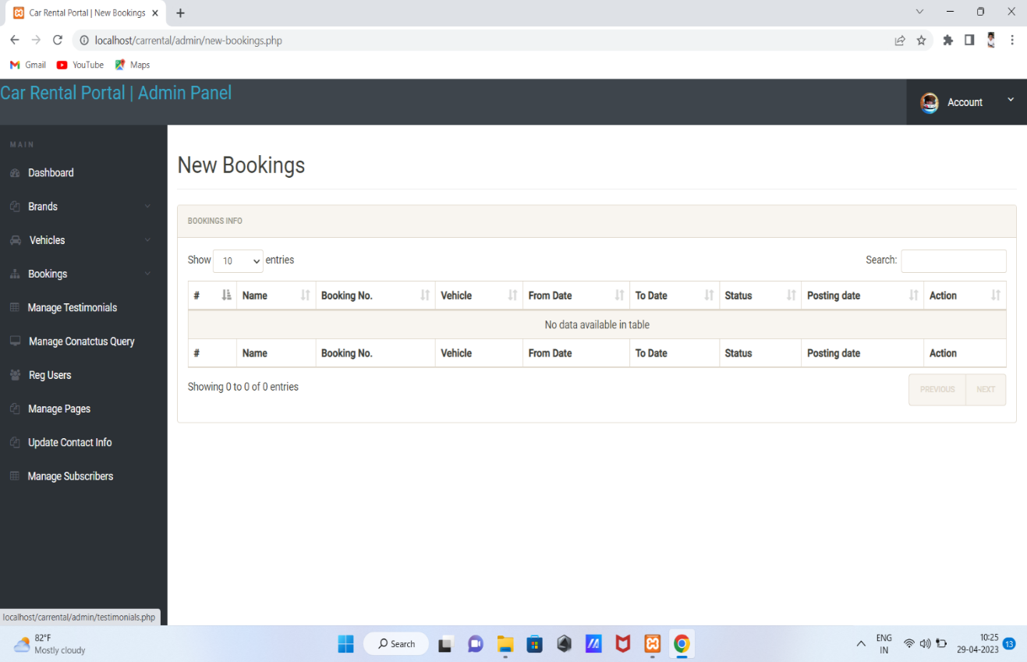

Figure 5.2.5 New Booking details DB

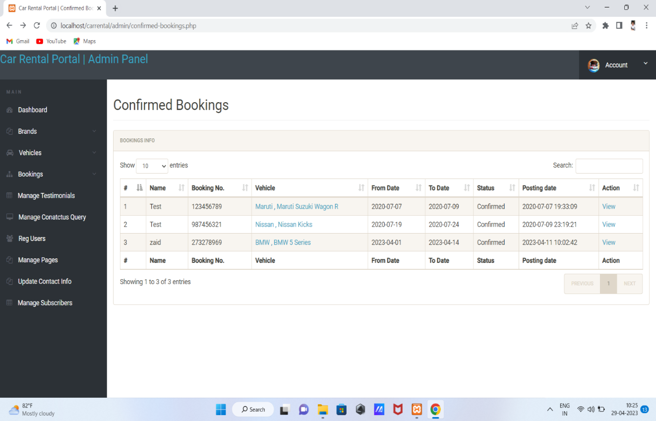

Figure 5.2.6 Confirmed bookings DB

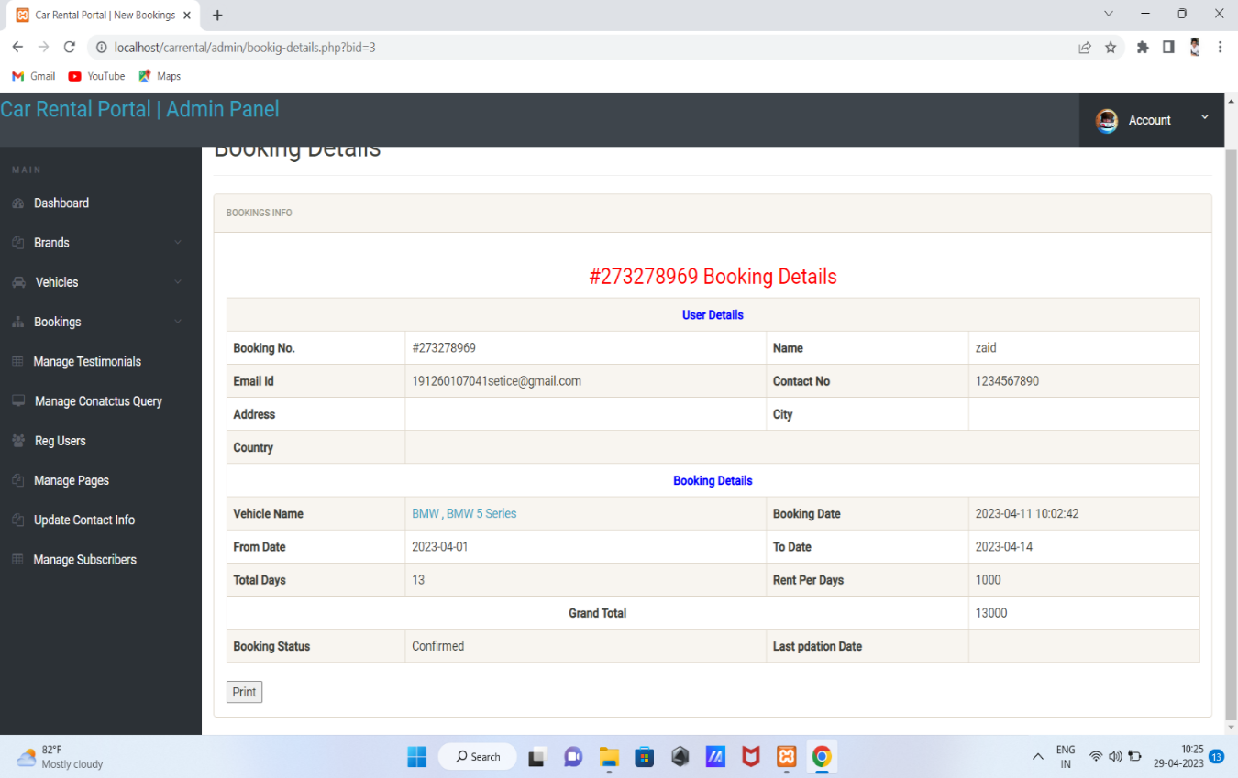

Figure 5.2.7 Booking details DB

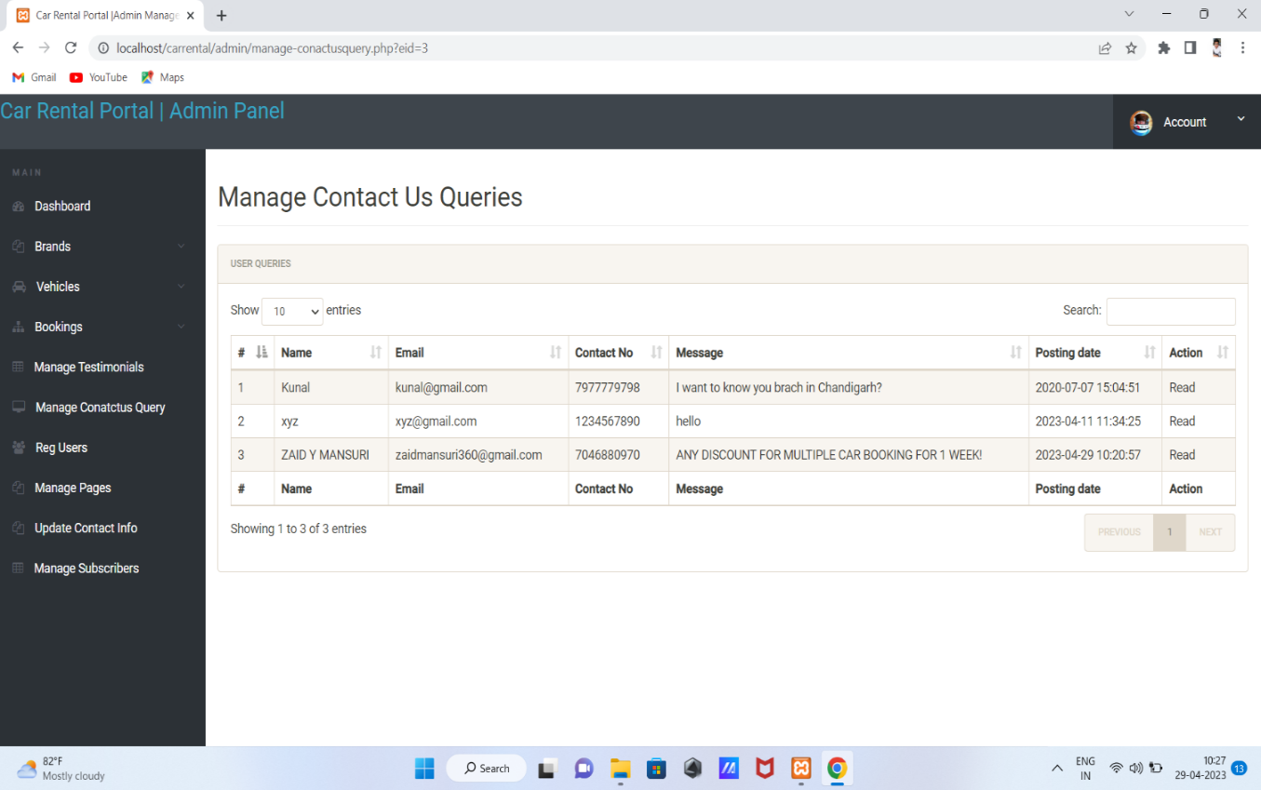

Figure 5.2.8 Contact Us DB

## 5.3 System Procedural Design

**5.3.1 Design Pseudo code or algorithm for method or operation**

### Admin Side

Step 1: Enter the URL to open the system

Step 2: Click on Login Button for Login

Step 3: Provide user name and password

Step 4: If username and password both is correct then it will login successfully.

Step 5: It shows Admin page

Step 6: Admin can able to perform Many operations and Also Access to all pages.

Step 7: Admin contain service request which include UserId status (New, pending,

Completed).

### User Side

Step 1: Enter the URL to open the system

Step 2: Click on Login Button for Login

Step 3: Provide user name and password

Step 4: If username and password both is correct then it will login successfully.

Step 5: It shows home page

Step 6: It will Book the Services and also show that book service on customer

Dashboard.

Step 7: Logout User.

### Service Provider

Step 1: Enter the URL to open the system

Step 2: Click on Login Button for Login

Step 3: Provide user name and password

Step 4: If username and password both is correct then it will login successfully.

Step 5: It shows home page

Step 6: Service Provider contain New Service Request which is able to accept

Service.

Step 7: Service Provider contain Upcoming Services which is able cancel the request.

Step 8: Service Provider contain Rating to rate service provider and also show history.

Step 9: Logout from Service Provider

**5.3.2 Flow Chart**

### Admin

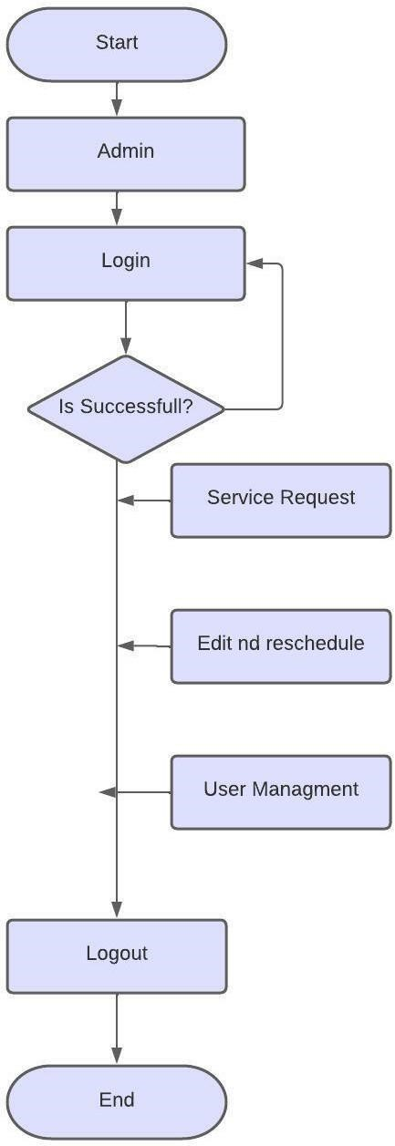

Figure 5.3.2.1 admin flow chart

### User

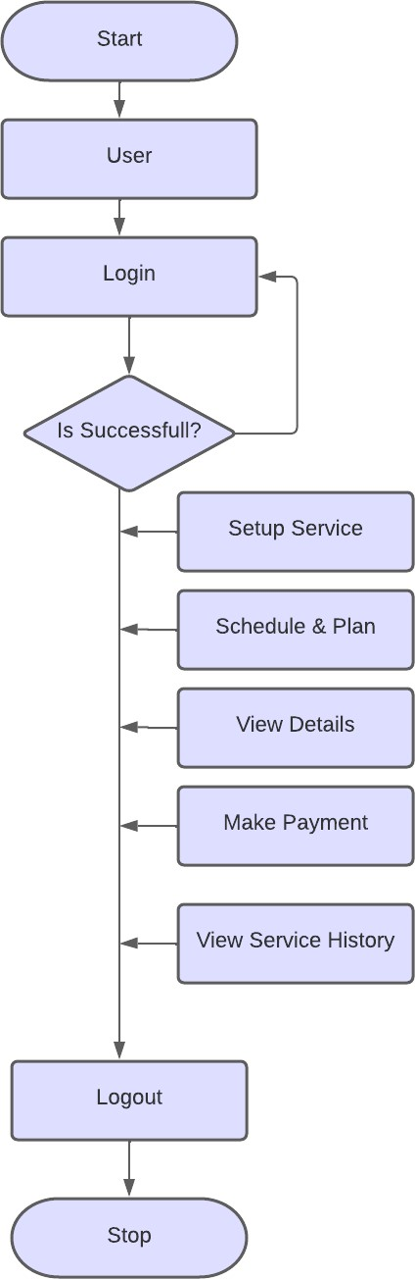

Figure 5.3.2.3 users flow chart

### 5.3.3 State chart Diagram

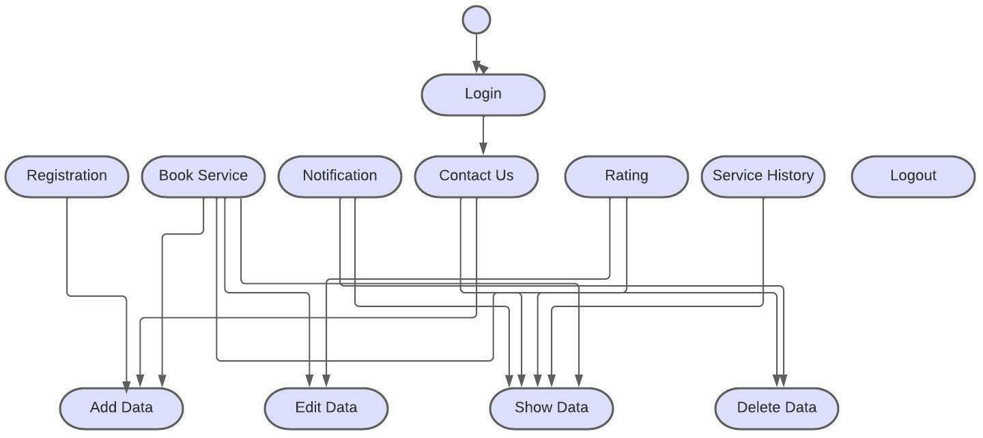

Figure 5.3.3.1 State Chart Diagram

# Implementation

## 6.1 Implementation Platform

* Our project is suitable to all type of users like single and multi-users.
* Multi users are allowed to operate the website at the same time.
* We provide the interface which is user friendly.
* We have GUI (graphical user interface) by which all type of users can easily access the application.
* One user at a time and also multi users can access the website at the same time and use all the services.
* If we don’t provide the GUI in the website then user won’t like our website.
* For better performance and reliability, we have to include GUI in the website.
* So, for the more security and performance we have to use the GUI

## 6.2 Technology Specification

### User Authentication

* Identification and authentication are used to establish a user's identity.
* Each user is required to log in to the system.

### Password Protection

• Every user who is to be allowed to access the portal is given his own username and password and given his own access rights so that only authorized and authenticated users can access the project.

### Confidentiality

* We provide confidentiality to all the users.
* In that one user cannot access the data of the other users.
* For that we provide one key to each user to secure its data.

### Scalability

* We provide the scalable website to make sure that every user can access the website in a proper order.
* User likes those type of website which are in one particular order that user cannot wait for the usage of the services.

## 6.3 Results

### Login

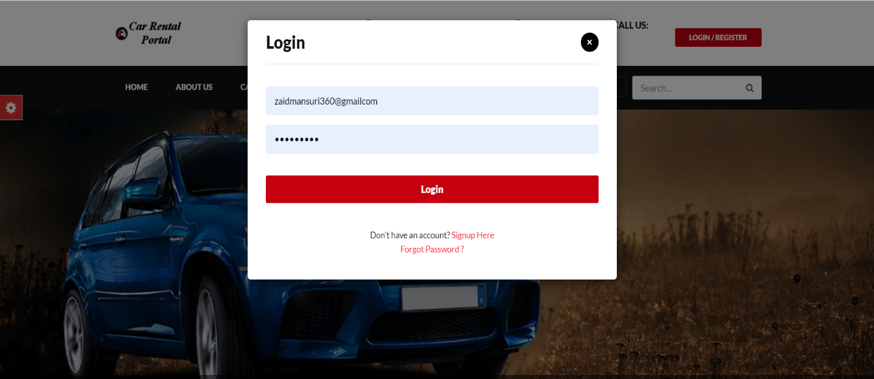

Figure 6.3.1 Login

### Forgot Password

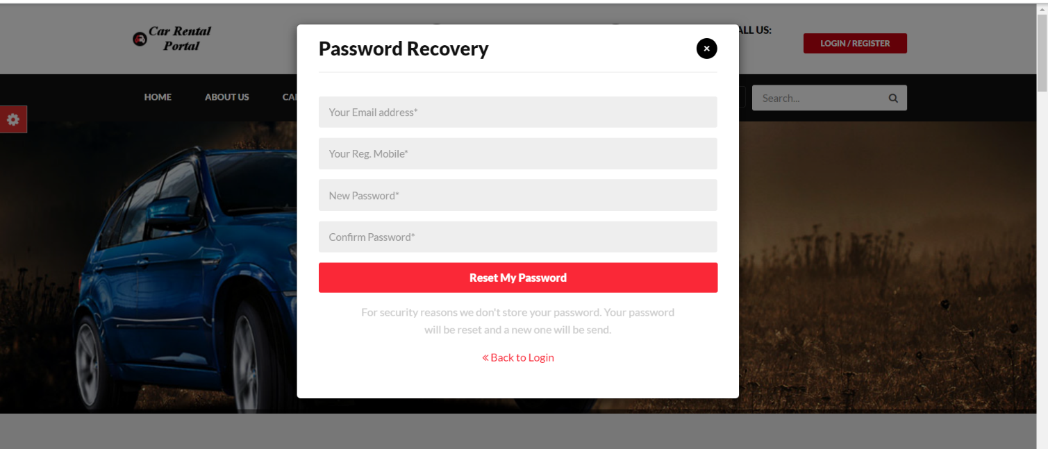

Figure 6.3.2 Forgot Password

### Customer Create Account

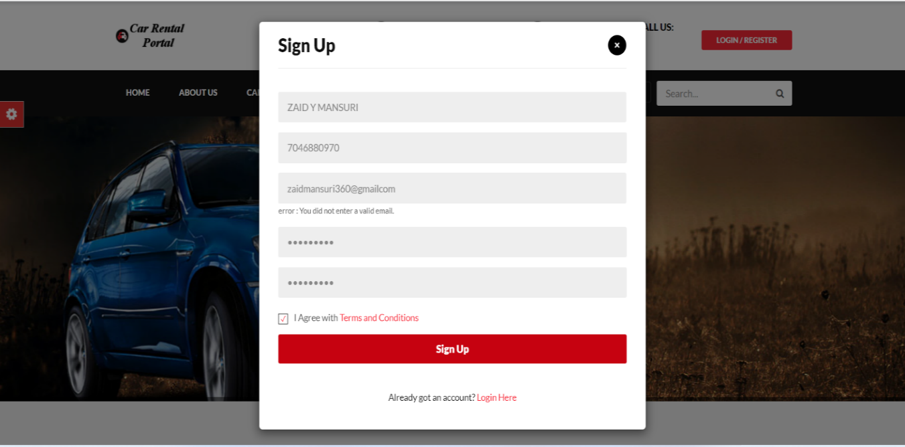

Figure 6.3.3 Customer Create Account

### Service Providers Create Account

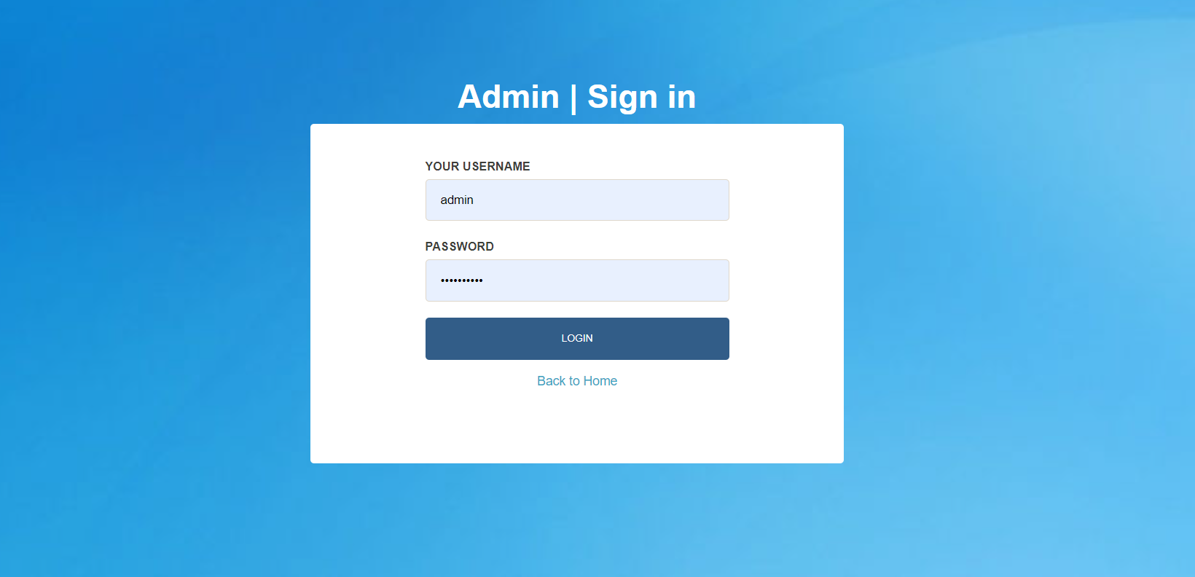

Figure 6.3.4 Service Provider Create Account

### Public Dashboard

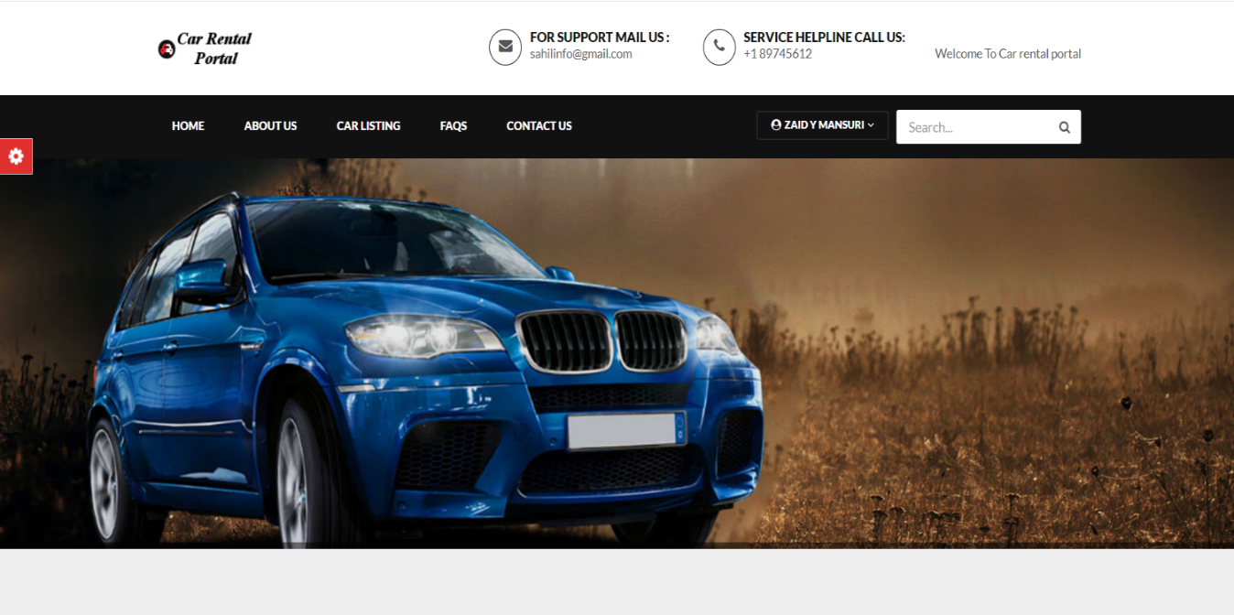

Figure 6.3.5 Public dashboard

### Service Providers Dashboard

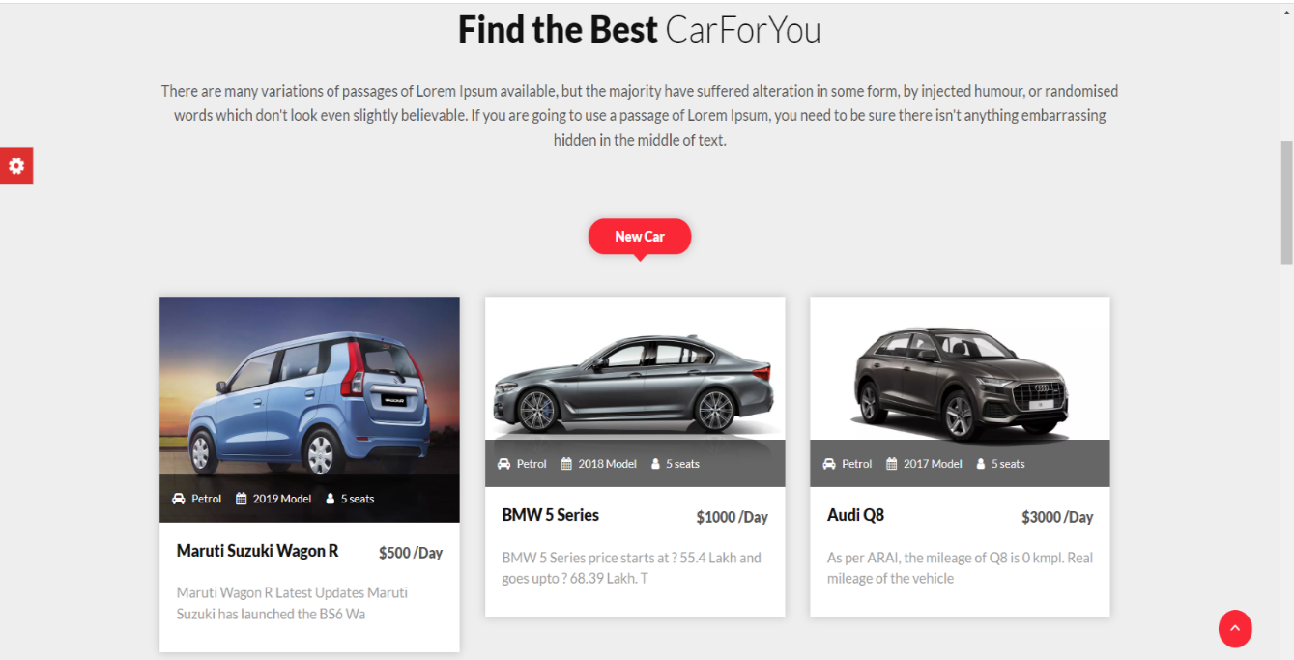

Figure 6.3.6 Service Providers Dashboard

### Service Providers Upcoming Service

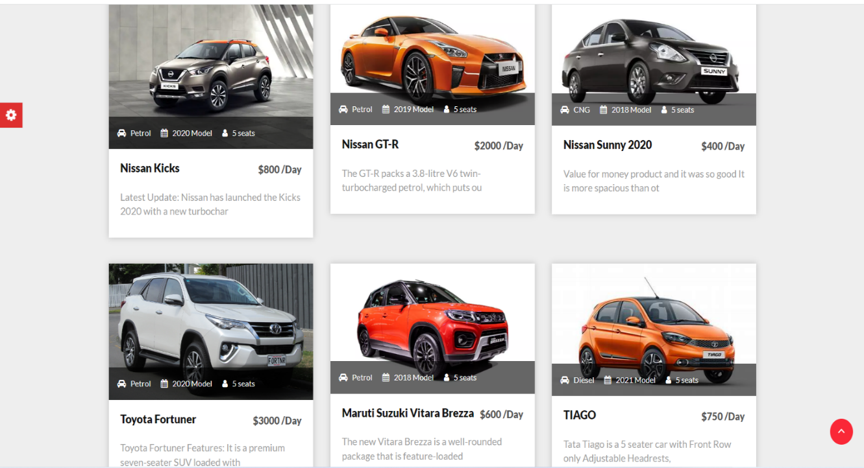

Figure 6.3.7 Service Providers Upcoming Service

### Service Provider Modals

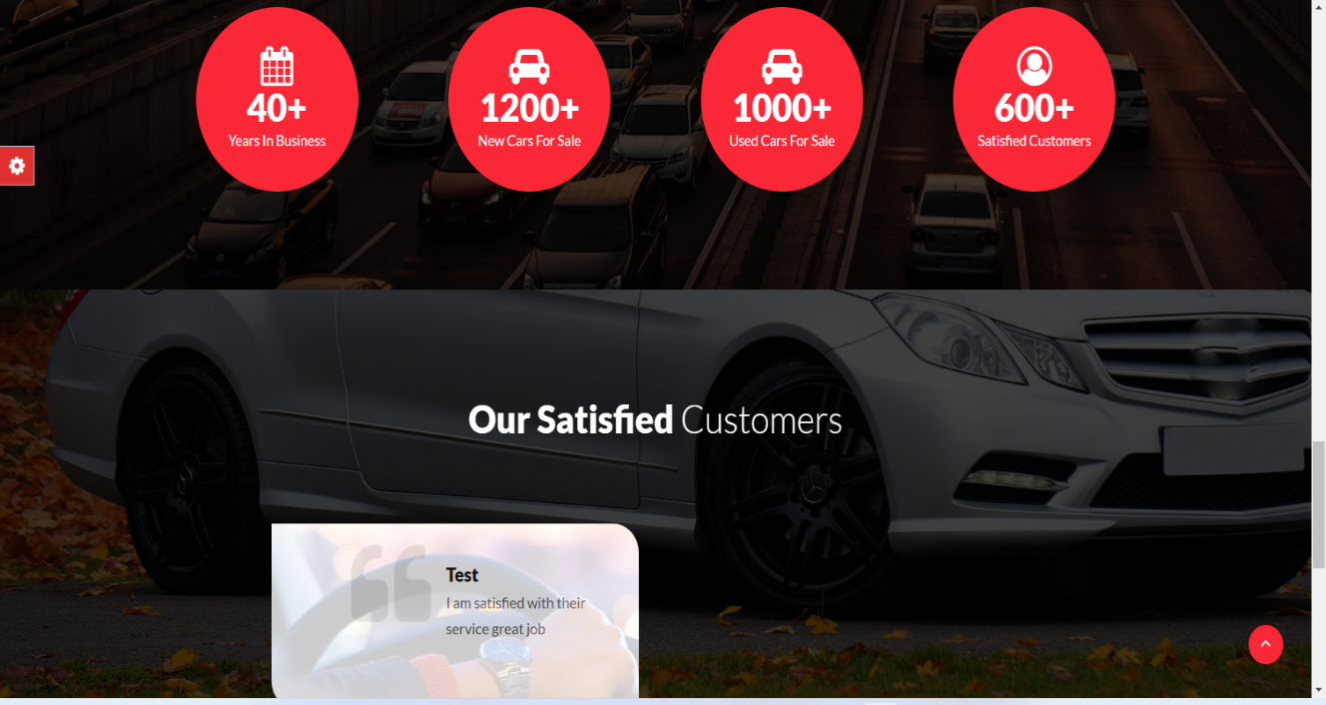

Figure 6.3.8 Service Providers Modal

### Service Schedule

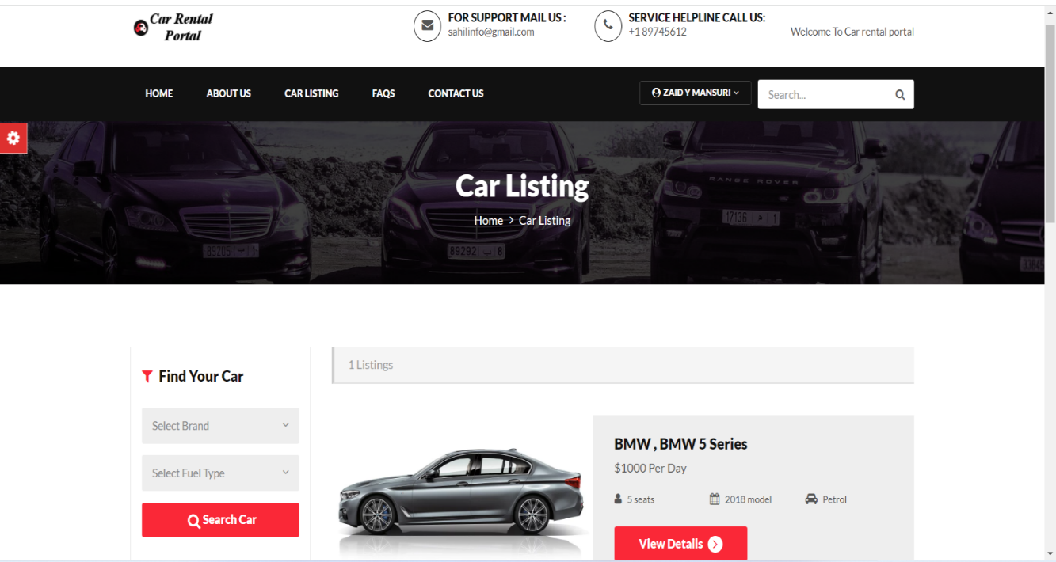

Figure 6.3.9 Car listing

### Service Providers Ratings

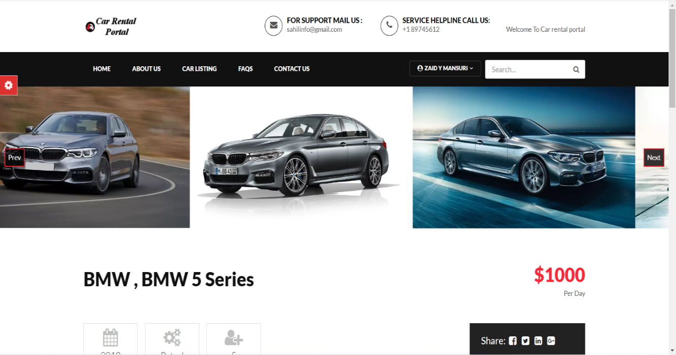

**Figure 6.3.10 cars images**

### Block Customer

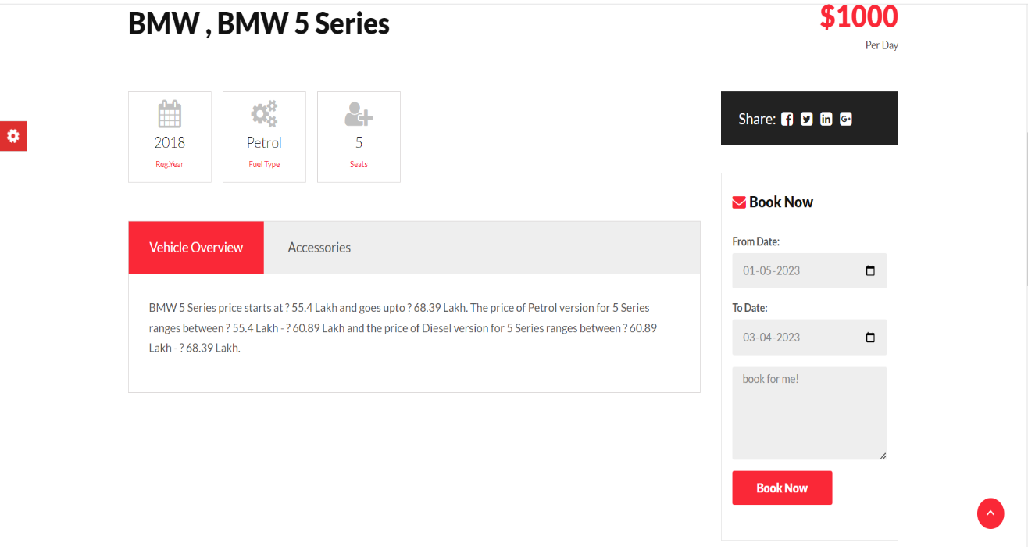

Figure 6.3.11 Details

### Log Out

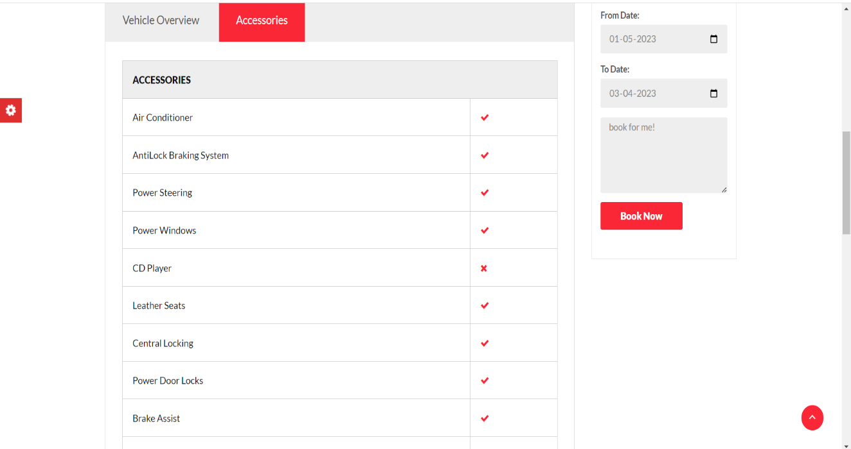

Figure 6.3.12 Accessories and booking

### Customer Dashboard

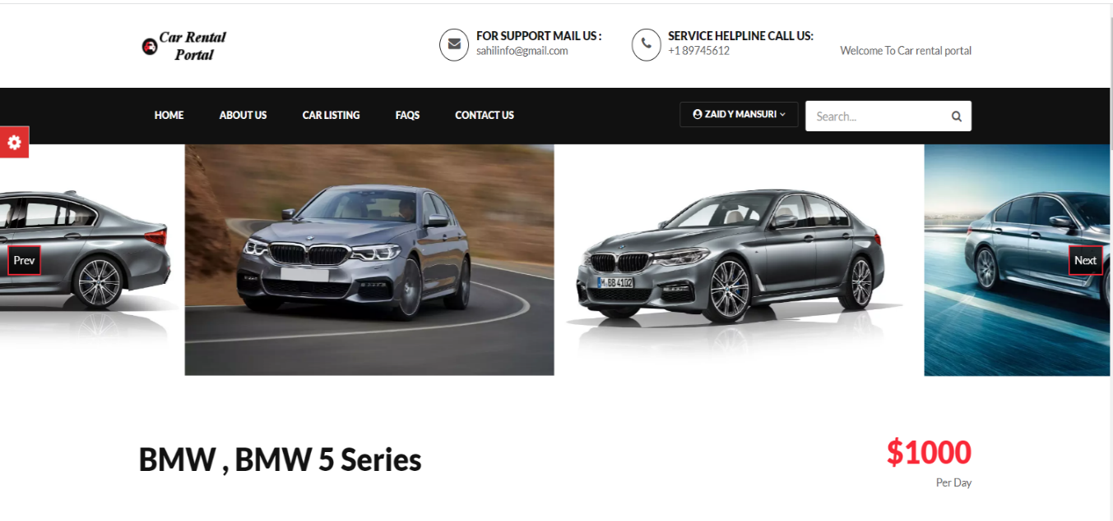

Figure 6.3.13 Customer Dashboard

### Service History

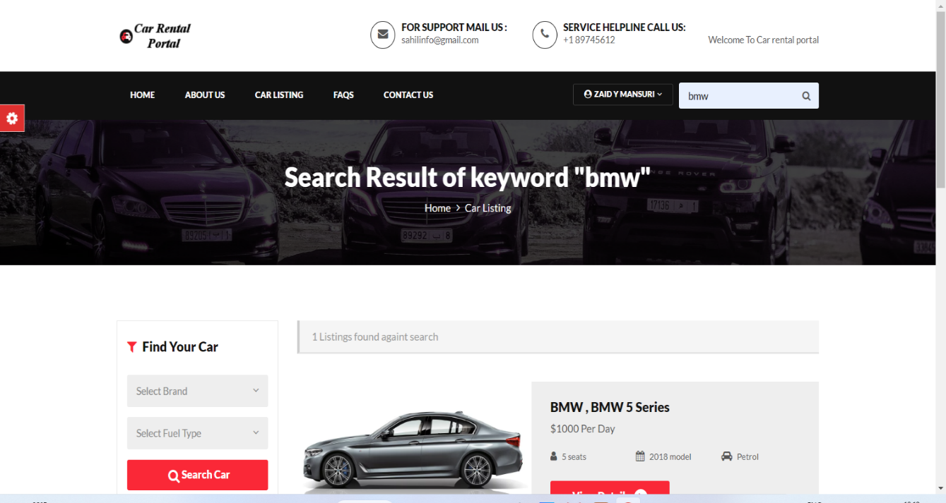

Figure 6.3.14 Search

### Book Service

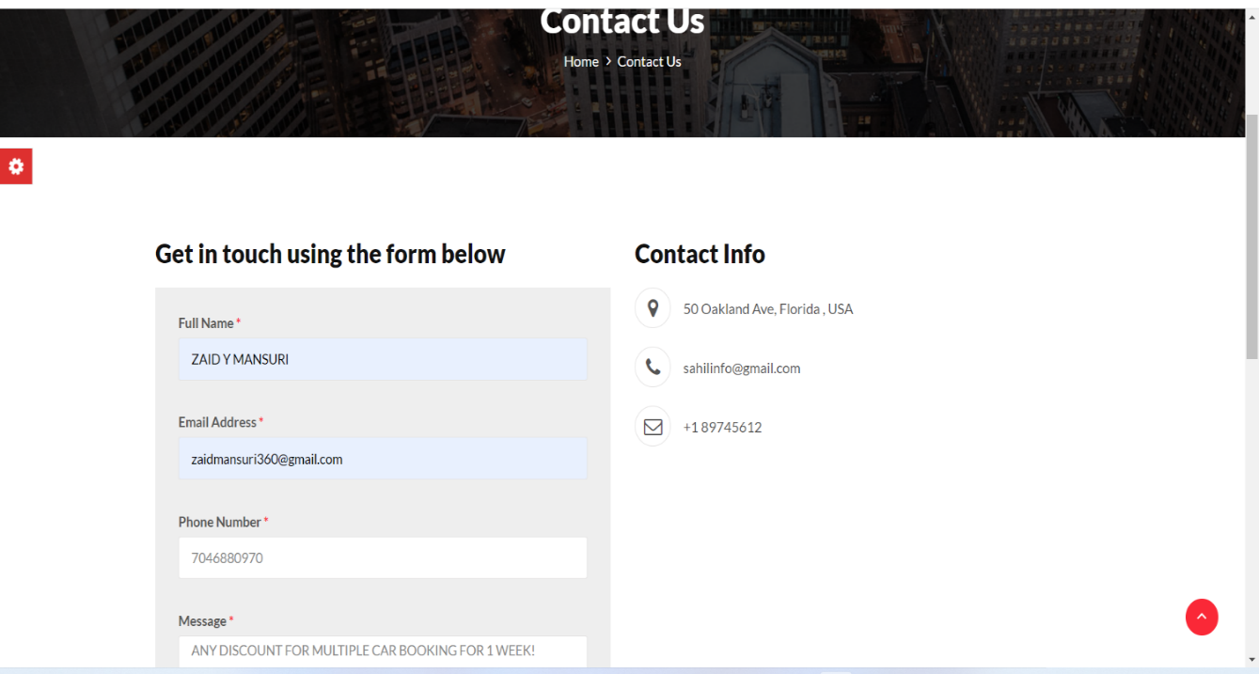

Figure 6.3.15 contact us

### Admin Dashboard

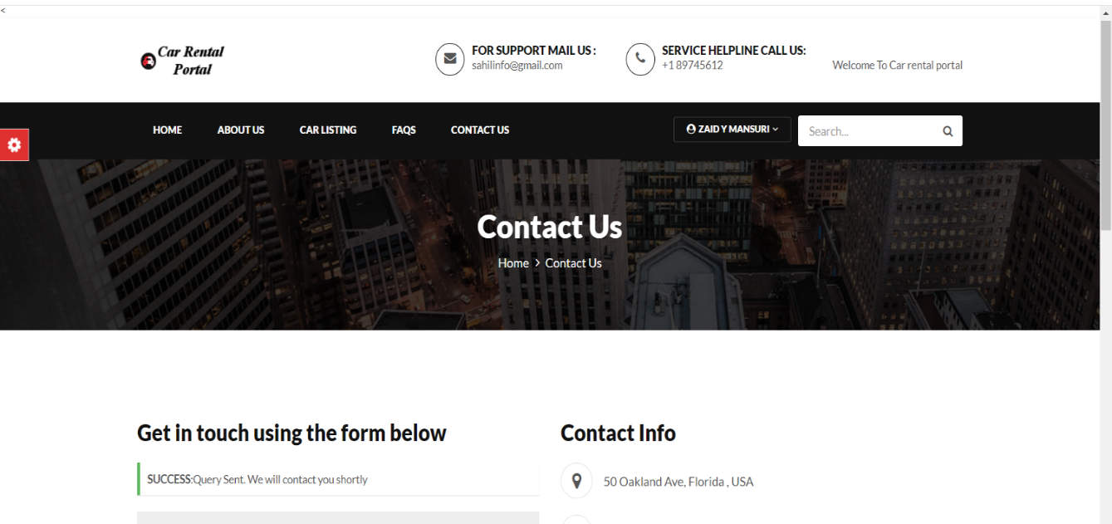

Figure 6.3.16 form submitted

# Testing

## 7.1 Testing Plan/ Strategy

In this project we have done the manual testing to verify that all our functionality works properly or not. The testing process is carried out when we had completed the implementation of all the functionality So here the testing had been done at the end of the internship.

In this project, we have done the functional testing that check each functionality works properly or not. All the testing procedure is carried out manually. All the testing procedure is carried out form 23rd March to 25th March.

First of all, we create the test cases for each functionality and what should be our expected output should be note down. Then we check all the functionality and check the actual output and compare with expected output. If match then we can pass the test case else we have to gave the remarks that what changes should have to done.

Testing

## 7.2 Test Results and Analysis

### 7.2.1 Test Cases

Table 7.2.1 Test Case

|  |  |  |  |  |
| --- | --- | --- | --- | --- |
| **Test ID** | **Test Condition** | **Expected Output** | **Actual Output** | **Remark** |
| 1 | Email Should be  Sent after Contact  Us Page  Submit | Send the Email with all details | Perfectly Send the  Email with all details | No |
| 2 | Customer  Authentication  Functionality | Login, Logout, Create Account should be done properly. | Done Properly all the Authentication functionality | No |
| 3 | Book the Service | Properly user can book the service with all the proper details. | All the details should be saved properly and done the book service perfectly | No |
| 4 | Customer Pages | Customer can see all the service history, upcoming service,  Profile, favorites pros | All the customer pages had properly displayed all the  details | No |
| 5 | Service Provider  Pages | SP can see all the new requests, service history, ratings, profile, block customer. | All the SP pages had properly displayed all the details. | No |
| 6 | Admin Screens | Admin can manage all the service request and managed all the users | Admin managed all the things properly | No |

# Conclusion and Discussion

## 8.1 Overall Analysis of Internship

During the internship first of all they gave the basic knowledge of our languages and then they gave the project. In project first of all we have to design the webpages according they have given as per the SRS (Software Requirements Specification) then we have to design the databases for our website. After designing the database, we have to integrate all the webpages with database and lastly, we have to do testing of our website. After completing the project, we have to upload the project to the GitHub.

## 8.2 Dates of surprise visit by institute mentor

➢Mentor:-Jignyasa Gandhi

➢ Date: - 11/04/2023

## 8.3 Dates of Continuous Evaluation (CE-I and CE-II)

* CE-1 10/02/2023
* CE-2 05/05/2023

## 8.4 Problem Encountered and Possible Solutions

Sometimes the problem occurred that suppose two customers tried to book the same service, same location and same time slot then in the database concurrency problem arises.

So, there would be possible solutions that in our algorithms we have to implement the synchronization methods so by implementing this method the concurrency issues solved.

Another problem that we have to enhanced the distance calculation between the customer and service providers by using the third-party libraries or APIs. As more efficient the calculation of distance more efficient would be assigned the service providers properly.

## 8.5 Summary of Internship

During Internship they have assign the project name E-CAR. So, the E-CAR is a platform where the user can book a car on rent according to their requirement like brand and accessories of a car.

## 8.6 Conclusion

Car rental business has emerged with a new goodies compared to the past experience where every activity concerning car rental business is limited to a physical location only. Even though the physical location has not been totally eradicated; the nature of functions and how these functions are achieved has been reshaped by the power of internet. Nowadays, customers can reserve cars online, rent car online, and have the car brought to their door step once the customer is a registered member or go to the office to pick the car.

## 8.7 Limitation and Future Enhancement

The web based car rental system has offered an advantage to both customers as well as Car Rental Company to efficiently and effectively manage the business and satisfies customers' need at the click of a button.

# References

* <https://www.w3schools.com/html/>
* <https://javascript.info/>
* <https://getbootstrap.com/>
* <https://www.tutorialspoint.com/css/index.htm>